Project on  
**eBook Store**  
using ASP.NET with C#, LINQ and Entity Framework

*Submitted by*

Sukhpreet Singh Anand  
WBUT Registration Number: 121480110116  
WBUT Roll Number: 14800112165

Department of Computer Science and Engineering  
FUTURE INSTITUTE OF ENGINEERING AND MANAGEMENT, KOLKATA  
(Affiliated to West Bengal University of Technology)

# Project Certificate

To whom it may concern,

This is to state that Mr. SUKHPREET SINGH ANAND has completed the project on

“eBook Store”

Using ASP.NET with C#, LINQ and Entity Framework under the guidance of Mr. SAYANTAN BASU.

from 18th June, 2015 to 23rd July, 2015

___________________________________

Mr. Sayantan Basu

Faculty

CMC Park Street

# Index

Project Abstract 4

User Manual 5

Software Requirement Specifications 7

Data Flow Diagram 8   
 *Level 0 8  
 Level 1 9  
 Level 2 10*

Entity Relationship Diagram 11

Entity Framework Designer Model 12

SQL Server Database diagram 13

Source Code 14

Screenshots 70

Future Scope 79

Bibliography 80

# Project Abstract

The eBook Store is a simple and interactive online store to purchase and download eBooks. Users can browse for books online, search them based on author, title, or even a category that the book belongs to. The books can be a free or a paid one for which the user can pay via an online payment method. These eBooks can be read on devices like phones, laptops and tablets using any standard digital document viewer.

This eBook Store has been designed using .NET Framework and Microsoft SQL Server. The website is accessible via any browser, and on any device. The user can search for books, add them to the cart and then proceed with the billing procedure. After the bill is generated, the user will get access to the download links of the books. These links will be available for the user all the time. For all these, however, the user needs to create an account by providing minimum yet relevant details. Without signing in, the user can simply view the books and their reviews, and rate them if they wish. A registered user can also write reviews and rate them.

The website administrator is the store vendor. The vendor is provided secure access to the website by entering his/her details directly to the specific SQL Server database. The administrator can add and maintain a list of Authors, Categories and Titles individually. A book that can be downloaded or a purchase is only made available when the administrator uses the dedicated upload wizard to upload an eBook file for the title and a cover image, associates the title with one or many authors and categories. Once the upload wizard reaches the last stage, an upload summary is provided and the book is made available to the user. Prior to that, any of the listed details, like authors, or titles will not be available to the user.

For security purposes and compatibility, the state management is completely managed on the server side. Therefore, using sessions, both the admin and the user are logged in to the website. The cart is even maintained in the sessions, allowing the user to quickly clear all items by closing and reopening the browser. No cookies are stored locally, making the interaction secure and fast. Also, user passwords are encrypted to provide extra security.

# User Manual

*This section explains how any user will use the eBook Store.*

1. The home page allows a user to search for a title, an author or the category itself. The search function allows takes the user to the search results page from which contains all the relevant details. The home page also contains the newest eBooks that are made available for download.
2. From the search results page allows the user to further perform searches and select an eBook that the users like. On clicking the link, it will take the user to the page containing the details of the eBook title.
3. On the title page, a user can view all the details of the title. The user can also rate the title and read the reviews. However, the user cannot post reviews of the title. To post reviews, the user much be signed in. Also, to shortlist the book, the user can add it to the cart. But for that the user must be signed in too.
4. The user can go to the login page from any page of the website, and also by clicking to the “Add to Cart” button, when not signed in. The user can also specify how long he or she wants to be signed in.
5. If the user does not have an account, the user can register using the Register link provided on all pages.
6. The user registration page takes from the user the minimum and required details for making the eBook purchase. Once registered, the user is taken to the home page from where the user can log in.
7. Once the user has added an item to the cart, he or she can view the cart to further modify the list of items in the cart. After finalizing the list, he or she can make the payment.
8. Once the payment is made, the user can view the orders, and the download links to the eBooks.
9. The vendor is the administrator who makes the books available for download. The details of the vendor or the administrator is directly added to the database. In this case, SQL Server Management Studio 2014 is used.
10. Once data is entered into the database, the admin can log in to the admin section of the website. This will take the admin to the Landing page from where the user can add lists of authors, categories and titles and then make them available for upload.
11. There are pages for authors, categories and titles that enlists the available authors, categories and titles and provide basic CRUD functionality.
12. The upload wizard is used to make an eBook available to the customer. The upload wizard allows the admin to first select a title to make available to the customer. Then the admin can add authors and categories for the book. Then the eBook file is uploaded and then, a cover photo is uploaded. Finally, the upload summary is shown to the admin.
13. There is also another section that allows the admin to remove inappropriate reviews.

# Software Requirement Specifications

## Hardware Requirements

The following are the **minimum** hardware requirements to host the website in a server and have the IDE along with it for debugging. The hard drive space is an estimated space required for 10 users and 10 eBooks.

* 1.6 GHz or faster processor
* 1 GB of RAM (1.5 GB if running on a virtual machine)
* 30 GB of available hard disk space
* 5400 RPM hard disk drive
* DirectX 9-capable video card that runs at 1024 x 768 or higher display resolution

## Software Requirements

**Supported operating systems**

* Windows 10 (x86 and x64)
* Windows 8.1 (x86 and x64)
* Windows 8 (x86 and x64)
* Windows 7 SP1 (x86 and x64)
* Windows Server 2012 R2 (x64)
* Windows Server 2012 (x64)
* Windows Server 2008 R2 SP1 (x64)

**Framework:** .NET Framework 4.0

**Database:** SQL Server 2014 Express

**Browser:** Any

*Microsoft Edge, Internet Explorer 11, or Firefox 39 or higher is recommended.*

**Web Server:** Internet Information Services 10

**IDE:** Visual Studio 2015

*This version of Visual Studio works best with Microsoft Edge or Internet Explorer 11. If Internet Explorer 11 is not installed on your computer, some features might not work as expected.*

**ORM:** Entity Framework 5.0

# Data Flow Diagram

## Level 0

## 

## Level 1

# 

## Level 2

# 

# Entity Relationship Diagram

# 

# Entity Designer Diagram

# 

# SQL Server Database Diagram

# 

# Source Code

./Admin/CRUD/Auth.aspx.cs

using System;

using System.Collections.Generic;

using System.Linq;

using System.Web;

using System.Web.UI;

using System.Web.UI.WebControls;

public partial class Admin_CRUD_Auth : System.Web.UI.Page

{

eBookStoreDBModelContainer ebs;

private void AuthUser()

{

try

{

lblMsg.Text = Session["eStoreAdmin"].ToString();

}

catch (Exception)

{

Response.Redirect("../Login.aspx");

}

}

public void GenData()

{

try

{

var query = from a in ebs.Authors

select a;

gvAuth.DataSource = query.ToList();

gvAuth.DataBind();

var query1 = from au in ebs.Authors

select new

{

au.AuthorId,

Name = string.Concat(au.FirstName, " ", au.LastName)

};

ddlAuth.DataSource = query1.ToList().OrderBy(a => a.Name);

ddlAuth.DataValueField = "AuthorId";

ddlAuth.DataTextField = "Name";

ddlAuth.DataBind();

}

catch (Exception ex)

{

lblErr.Text = ex.Message;

}

}

protected void Page_Load(object sender, EventArgs e)

{

ebs = new eBookStoreDBModelContainer();

AuthUser();

if (!IsPostBack)

{

GenData();

}

try

{

if (!IsPostBack)

{

lblMsg.Text = Session["eStoreAdmin"].ToString();

}

}

catch (Exception)

{

Response.Redirect("../Login.aspx");

}

}

protected void btnAdd_Click(object sender, EventArgs e)

{

try

{

Author au = new Author();

au.FirstName = txtAddFname.Text;

au.LastName = txtAddLName.Text;

ebs.Authors.Add(au);

ebs.SaveChanges();

GenData();

}

catch (Exception ex)

{

lblErr.Text = ex.Message;

}

}

protected void btnDel_Click(object sender, EventArgs e)

{

try

{

int authid = Int32.Parse(ddlAuth.SelectedItem.Value);

Author au = ebs.Authors.SingleOrDefault(a => a.AuthorId == authid);

if (au != null)

{

ebs.Authors.Remove(au);

ebs.SaveChanges();

GenData();

}

}

catch (Exception ex)

{

lblErr.Text = ex.Message;

}

}

protected void btnFill_Click(object sender, EventArgs e)

{

try

{

int authid = Int32.Parse(ddlAuth.SelectedItem.Value);

Author au = ebs.Authors.SingleOrDefault(a => a.AuthorId == authid);

if (au != null)

{

txtUpdtFName.Text = au.FirstName;

txtUpdtLName.Text = au.LastName;

}

}

catch (Exception ex)

{

lblErr.Text = ex.Message;

}

}

protected void btnUpdt_Click(object sender, EventArgs e)

{

try

{

int authid = Int32.Parse(ddlAuth.SelectedItem.Value);

Author au = ebs.Authors.SingleOrDefault(a => a.AuthorId == authid);

au.FirstName = txtUpdtFName.Text;

au.LastName = txtUpdtLName.Text;

ebs.SaveChanges();

GenData();

}

catch (Exception ex)

{

lblErr.Text = ex.Message;

}

}

protected void lbLogOut_Click(object sender, EventArgs e)

{

Session.Abandon();

Response.Redirect("Login.aspx");

}

}

./Admin/CRUD/Cat.aspx.cs

using System;

using System.Collections.Generic;

using System.Linq;

using System.Web;

using System.Web.UI;

using System.Web.UI.WebControls;

public partial class Admin_CRUD_Cat : System.Web.UI.Page

{

eBookStoreDBModelContainer ebs;

private void AuthUser()

{

try

{

lblMsg.Text = Session["eStoreAdmin"].ToString();

}

catch (Exception)

{

Response.Redirect("../Login.aspx");

}

}

public void GenData()

{

try

{

var query = from a in ebs.Categories

select a;

gvCat.DataSource = query.ToList();

gvCat.DataBind();

ddlCat.DataSource = query.ToList().OrderBy(a => a.CategoryName);

ddlCat.DataValueField = "CategoryID";

ddlCat.DataTextField = "CategoryName";

ddlCat.DataBind();

}

catch (Exception ex)

{

lblErr.Text = ex.Message;

}

}

protected void Page_Load(object sender, EventArgs e)

{

ebs = new eBookStoreDBModelContainer();

AuthUser();

if (!IsPostBack)

{

GenData();

}

try

{

if (!IsPostBack)

{

lblMsg.Text = Session["eStoreAdmin"].ToString();

}

}

catch (Exception)

{

Response.Redirect("../Login.aspx");

}

}

protected void btnAdd_Click(object sender, EventArgs e)

{

try

{

Category c = new Category();

c.CategoryName = txtAdd.Text;

ebs.Categories.Add(c);

ebs.SaveChanges();

GenData();

}

catch (Exception ex)

{

lblErr.Text = ex.Message;

}

}

protected void btnFill_Click(object sender, EventArgs e)

{

try

{

int catid = Int32.Parse(ddlCat.SelectedValue);

Category cat = ebs.Categories.SingleOrDefault(c => c.CategoryId == catid);

txtUpdt.Text = cat.CategoryName;

}

catch (Exception ex)

{

lblErr.Text = ex.Message;

}

}

protected void btnUpdt_Click(object sender, EventArgs e)

{

try

{

int catid = Int32.Parse(ddlCat.SelectedValue);

Category cat = ebs.Categories.SingleOrDefault(c => c.CategoryId == catid);

cat.CategoryName = txtUpdt.Text;

ebs.SaveChanges();

GenData();

}

catch (Exception ex)

{

lblErr.Text = ex.Message;

}

}

protected void btnDel_Click(object sender, EventArgs e)

{

try

{

int catid = Int32.Parse(ddlCat.SelectedValue);

Category cat = ebs.Categories.SingleOrDefault(c => c.CategoryId == catid);

if (cat != null)

{

ebs.Categories.Remove(cat);

ebs.SaveChanges();

GenData();

}

}

catch (Exception ex)

{

lblErr.Text = ex.Message;

}

}

protected void lbLogOut_Click(object sender, EventArgs e)

{

Session.Abandon();

Response.Redirect("Login.aspx");

}

protected void lbLanding_Click(object sender, EventArgs e)

{

Response.Redirect("../Landing.aspx");

}

}

./Admin/CRUD/Rev.aspx.cs

using System;

using System.Collections.Generic;

using System.Linq;

using System.Web;

using System.Web.UI;

using System.Web.UI.WebControls;

public partial class Admin_CRUD_Rev : System.Web.UI.Page

{

eBookStoreDBModelContainer ebs;

private void AuthUser()

{

try

{

lblMsg.Text = Session["eStoreAdmin"].ToString();

}

catch (Exception)

{

Response.Redirect("../Login.aspx");

}

}

private void GenDataOuter()

{

// populate titiles list box

var queryTitles = from t in ebs.Titles

where t.Status == 1

select new

{

t.TitleId,

t.TitleName

};

lbTitle.DataSource = queryTitles.ToList().OrderBy(a => a.TitleName);

lbTitle.DataTextField = "TitleName";

lbTitle.DataValueField = "TitleId";

lbTitle.DataBind();

}

private void GenDataInner()

{

if (lbTitle.Items.Count != 0)

{

if (!IsPostBack) lbTitle.SelectedIndex = 0;

//populate reviews in list box

int titleid = Int32.Parse(lbTitle.SelectedItem.Value);

var queryRev = from rev in ebs.Reviews

where rev.Title.TitleId == titleid

select new

{

rev.ReviewText,

rev.ReviewId

};

lbRev.DataSource = queryRev.ToList();

lbRev.DataTextField = "ReviewText";

lbRev.DataValueField = "ReviewId";

lbRev.DataBind();

}

}

protected void Page_Load(object sender, EventArgs e)

{

ebs = new eBookStoreDBModelContainer();

if (!IsPostBack)

{

GenDataOuter();

}

}

protected void btnDel_Click(object sender, EventArgs e)

{

int revid = Int32.Parse(lbRev.SelectedItem.Value);

Review rev = ebs.Reviews.SingleOrDefault(a => a.ReviewId == revid);

ebs.Reviews.Remove(rev);

ebs.SaveChanges();

GenDataInner();

}

protected void btnShow_Click(object sender, EventArgs e)

{

GenDataInner();

}

protected void lbLogOut_Click(object sender, EventArgs e)

{

Session.Abandon();

Response.Redirect("Login.aspx");

}

protected void lbLanding_Click(object sender, EventArgs e)

{

Response.Redirect("../Landing.aspx");

}

}

./Admin/CRUD/Title.aspx.cs

using System;

using System.Collections.Generic;

using System.Linq;

using System.Web;

using System.Web.UI;

using System.Web.UI.WebControls;

public partial class Admin_CRUD_Title : System.Web.UI.Page

{

eBookStoreDBModelContainer ebs;

private void AuthUser()

{

try

{

lblMsg.Text = Session["eStoreAdmin"].ToString();

}

catch (Exception)

{

Response.Redirect("../Login.aspx");

}

}

public void GenData()

{

try

{

var query = from a in ebs.Titles

select a;

gvTitle.DataSource = query.ToList();

gvTitle.DataBind();

var query1 = from a in ebs.Titles

select new

{

a.TitleId,

Name = string.Concat(a.TitleName, " (", a.Edition, ") ")

};

ddlTitle.DataSource = query1.ToList().OrderBy(a => a.Name);

ddlTitle.DataTextField = "Name";

ddlTitle.DataValueField = "TitleId";

ddlTitle.DataBind();

}

catch (Exception ex)

{

lblErr.Text = ex.Message;

}

}

protected void Page_Load(object sender, EventArgs e)

{

ebs = new eBookStoreDBModelContainer();

AuthUser();

if (!IsPostBack)

{

GenData();

}

try

{

if (!IsPostBack)

{

lblMsg.Text = Session["eStoreAdmin"].ToString();

}

}

catch (Exception)

{

Response.Redirect("../Login.aspx");

}

}

protected void btnAdd_Click(object sender, EventArgs e)

{

try

{

Title ttl = new Title();

ttl.TitleName = txtName.Text;

ttl.TitleDescription = txtDesc.Text;

ttl.Edition = txtEd.Text;

ttl.ISBN = txtISBN.Text;

ttl.Pages = Int32.Parse(txtPgs.Text);

ttl.PubDate = Convert.ToDateTime(txtPubDate.Text);

ttl.Rating = 0;

ttl.RatingCount = 0;

ttl.DownloadCount = 0;

ttl.Status = 0;

ttl.FileFormat = ddlFormat.SelectedValue;

ttl.Price = Decimal.Parse(txtPrice.Text);

ebs.Titles.Add(ttl);

ebs.SaveChanges();

GenData();

}

catch (Exception ex)

{

lblErr.Text = ex.Message;

}

}

protected void btnFill_Click(object sender, EventArgs e)

{

try

{

int tid = Int32.Parse(ddlTitle.SelectedValue);

Title ttl = ebs.Titles.SingleOrDefault(t => t.TitleId == tid);

txtName.Text = ttl.TitleName;

txtDesc.Text = ttl.TitleDescription;

txtEd.Text = ttl.Edition;

txtISBN.Text = ttl.ISBN.ToString();

txtPgs.Text = ttl.Pages.ToString();

txtPubDate.Text = ttl.PubDate.ToShortDateString();

txtPrice.Text = ttl.Price.ToString();

}

catch (Exception ex)

{

lblErr.Text = ex.Message;

}

}

protected void btnUpdt_Click(object sender, EventArgs e)

{

try

{

int tid = Int32.Parse(ddlTitle.SelectedValue);

Title ttl = ebs.Titles.SingleOrDefault(t => t.TitleId == tid);

ttl.TitleName = txtName.Text;

ttl.TitleDescription = txtDesc.Text;

ttl.Edition = txtEd.Text;

ttl.ISBN = txtISBN.Text;

ttl.Pages = Int32.Parse(txtPgs.Text);

ttl.PubDate = Convert.ToDateTime(txtPubDate.Text);

ttl.FileFormat = ddlFormat.SelectedValue;

ttl.Price = Decimal.Parse(txtPrice.Text);

ebs.SaveChanges();

GenData();

}

catch (Exception ex)

{

lblErr.Text = ex.Message;

}

}

protected void btnDel_Click(object sender, EventArgs e)

{

try

{

int tid = Int32.Parse(ddlTitle.SelectedItem.Value);

Title ttl = ebs.Titles.SingleOrDefault(t => t.TitleId == tid);

ebs.Titles.Remove(ttl);

ebs.SaveChanges();

GenData();

}

catch (Exception ex)

{

lblErr.Text = ex.Message;

}

}

protected void lbLogOut_Click(object sender, EventArgs e)

{

Session.Abandon();

Response.Redirect("Login.aspx");

}

protected void lbLanding_Click(object sender, EventArgs e)

{

Response.Redirect("../Landing.aspx");

}

}

./Admin/UploadWiz/AssignAuthor.aspx.cs

using System;

using System.Collections.Generic;

using System.Linq;

using System.Web;

using System.Web.UI;

using System.Web.UI.WebControls;

public partial class Admin_UploadWiz_AssignAuthor : System.Web.UI.Page

{

eBookStoreDBModelContainer ebs;

private void AuthUser()

{

try

{

lblMsg.Text = Session["eStoreAdmin"].ToString();

}

catch (Exception)

{

Response.Redirect("../Login.aspx");

}

}

public void GenData()

{

int TitleId = Int32.Parse(Request.QueryString["TitleId"]);

var query = from a in ebs.Authors

select new

{

a.AuthorId,

Name = string.Concat(a.FirstName, " ", a.LastName)

};

ddlAllAuth.DataSource = query.ToList().OrderBy(a => a.Name);

ddlAllAuth.DataTextField = "Name";

ddlAllAuth.DataValueField = "AuthorId";

ddlAllAuth.DataBind();

var query1 = from au in ebs.Authors

from ttl in au.Titles

where ttl.TitleId == TitleId

select new

{

au.AuthorId,

Name = string.Concat(au.FirstName, " ", au.LastName)

};

ddlSelAuth.DataSource = query1.ToList().OrderBy(a => a.Name);

ddlSelAuth.DataTextField = "Name";

ddlSelAuth.DataValueField = "AuthorId";

ddlSelAuth.DataBind();

var query2 = from au in ebs.Authors

from ttl in au.Titles

where ttl.TitleId == TitleId

select new

{

Name = string.Concat(au.FirstName, " ", au.LastName)

};

gvAuth.DataSource = query2.ToList().OrderBy(n => n.Name);

gvAuth.DataBind();

}

protected void Page_Load(object sender, EventArgs e)

{

ebs = new eBookStoreDBModelContainer();

AuthUser();

try

{

if (!IsPostBack)

{

GenData();

}

int TitleId = Int32.Parse(Request.QueryString["TitleId"]);

Title t = ebs.Titles.SingleOrDefault(a => a.TitleId == TitleId);

lblTitle.Text = t.TitleName + " " + t.Edition + " edition.";

}

catch (Exception ex)

{

lblTitle.Text = "Undefined.";

lblErr.Text = ex.Message;

lblErr.Text += "<br> You probably arrived to this page directly.";

}

}

protected void btnNext_Click(object sender, EventArgs e)

{

if (ddlSelAuth.Items.Count != 0)

{

string TitleId = Request.QueryString["TitleId"];

Response.Redirect("AssignCategory.aspx?TitleId=" + TitleId);

}

else

{

lblErr.Text = "Select at least one author.";

}

}

protected void btnprev_Click(object sender, EventArgs e)

{

Response.Redirect("SelectTitle.aspx?=");

}

protected void btnAdd_Click(object sender, EventArgs e)

{

int AuthorId = Int32.Parse(ddlAllAuth.SelectedItem.Value);

int TitleId = Int32.Parse(Request.QueryString["TitleId"]);

Author au = ebs.Authors.Single(a => a.AuthorId == AuthorId);

Title t = ebs.Titles.SingleOrDefault(a => a.TitleId == TitleId);

t.Authors.Add(au);

ebs.SaveChanges();

GenData();

}

protected void btnDel_Click(object sender, EventArgs e)

{

int AuthorId = Int32.Parse(ddlSelAuth.SelectedItem.Value);

int TitleId = Int32.Parse(Request.QueryString["TitleId"]);

Author a = ebs.Authors.SingleOrDefault(au => au.AuthorId == AuthorId);

Title t = ebs.Titles.SingleOrDefault(ttl => ttl.TitleId == TitleId);

a.Titles.Remove(t);

ebs.SaveChanges();

GenData();

}

protected void lbLogOut_Click(object sender, EventArgs e)

{

Session.Abandon();

Response.Redirect("Login.aspx");

}

}

./Admin/UploadWiz/AssignCategory.aspx.cs

using System;

using System.Collections.Generic;

using System.Linq;

using System.Web;

using System.Web.UI;

using System.Web.UI.WebControls;

public partial class Admin_UploadWiz_AssignCategory : System.Web.UI.Page

{

eBookStoreDBModelContainer ebs;

private void AuthUser()

{

try

{

lblMsg.Text = Session["eStoreAdmin"].ToString();

}

catch (Exception)

{

Response.Redirect("../Login.aspx");

}

}

public void GenData()

{

int TitleId = Int32.Parse(Request.QueryString["TitleId"]);

var query = from c in ebs.Categories

select new

{

c.CategoryId,

c.CategoryName

};

ddlAllCat.DataSource = query.ToList().OrderBy(a => a.CategoryName);

ddlAllCat.DataTextField = "CategoryName";

ddlAllCat.DataValueField = "CategoryId";

ddlAllCat.DataBind();

var query1 = from c in ebs.Categories

from ttl in c.Titles

where ttl.TitleId == TitleId

select new

{

c.CategoryId,

c.CategoryName

};

ddlSelCat.DataSource = query1.ToList().OrderBy(a => a.CategoryName);

ddlSelCat.DataTextField = "CategoryName";

ddlSelCat.DataValueField = "CategoryId";

ddlSelCat.DataBind();

var query2 = from c in ebs.Categories

from ttl in c.Titles

where ttl.TitleId == TitleId

select new

{

c.CategoryName

};

gvCat.DataSource = query2.ToList().OrderBy(n => n.CategoryName);

gvCat.DataBind();

}

protected void Page_Load(object sender, EventArgs e)

{

ebs = new eBookStoreDBModelContainer();

AuthUser();

try

{

if (!IsPostBack)

{

GenData();

}

int TitleId = Int32.Parse(Request.QueryString["TitleId"]);

Title t = ebs.Titles.SingleOrDefault(a => a.TitleId == TitleId);

lblTitle.Text = t.TitleName + " " + t.Edition + " edition.";

}

catch (Exception ex)

{

lblTitle.Text = "Undefined.";

lblErr.Text = ex.Message;

lblErr.Text += "<br> You probably arrived to this page directly.";

}

}

protected void btnAdd_Click(object sender, EventArgs e)

{

int CatId = Int32.Parse(ddlAllCat.SelectedItem.Value);

int TitleId = Int32.Parse(Request.QueryString["TitleId"]);

Title ttl = ebs.Titles.SingleOrDefault(t => t.TitleId == TitleId);

Category cat = ebs.Categories.SingleOrDefault(c => c.CategoryId == CatId);

ttl.Categories.Add(cat);

ebs.SaveChanges();

GenData();

}

protected void btnDel_Click(object sender, EventArgs e)

{

int CatId = Int32.Parse(ddlSelCat.SelectedItem.Value);

int TitleId = Int32.Parse(Request.QueryString["TitleId"]);

Title ttl = ebs.Titles.SingleOrDefault(t => t.TitleId == TitleId);

Category cat = ebs.Categories.SingleOrDefault(c => c.CategoryId == CatId);

ttl.Categories.Remove(cat);

ebs.SaveChanges();

GenData();

}

protected void btnprev_Click(object sender, EventArgs e)

{

string TitleId = Request.QueryString["TitleId"];

Response.Redirect("AssignAuthor.aspx?TitleId=" + TitleId);

}

protected void btnNext_Click(object sender, EventArgs e)

{

if (ddlSelCat.Items.Count != 0)

{

string TitleId = Request.QueryString["TitleId"];

Response.Redirect("FileUpload.aspx?TitleId=" + TitleId);

}

else

{

lblErr.Text = "Select at least one category";

}

}

protected void lbLogOut_Click(object sender, EventArgs e)

{

Session.Abandon();

Response.Redirect("Login.aspx");

}

}

./Admin/UploadWiz/FileUpload.aspx.cs

using System;

using System.Collections.Generic;

using System.Linq;

using System.Web;

using System.Web.UI;

using System.Web.UI.WebControls;

public partial class Admin_UploadWiz_FileUpload : System.Web.UI.Page

{

eBookStoreDBModelContainer ebs;

private void AuthUser()

{

try

{

lblMsg.Text = Session["eStoreAdmin"].ToString();

}

catch (Exception)

{

Response.Redirect("../Login.aspx");

}

}

protected void Page_Load(object sender, EventArgs e)

{

ebs = new eBookStoreDBModelContainer();

AuthUser();

try

{

int TitleId = Int32.Parse(Request.QueryString["TitleId"]);

Title t = ebs.Titles.SingleOrDefault(a => a.TitleId == TitleId);

lblTitle.Text = t.TitleName + " " + t.Edition + " edition.";

}

catch (Exception ex)

{

lblTitle.Text = "Undefined.";

lblErr.Text = ex.Message;

lblErr.Text += "<br> You probably arrived to this page directly.";

}

}

protected void btnNext_Click(object sender, EventArgs e)

{

string TitleId = Request.QueryString["TitleId"];

Response.Redirect("ImageUpload.aspx?TitleId=" + TitleId);

}

protected void btnprev_Click(object sender, EventArgs e)

{

string TitleId = Request.QueryString["TitleId"];

Response.Redirect("AssignCategory.aspx?TitleId=" + TitleId);

}

protected void btnUpld_Click(object sender, EventArgs e)

{

try

{

if (FileUpload1.HasFile)

{

string TitleId = Request.QueryString["TitleId"];

string dirpath = Server.MapPath("../../Storage/Books/");

string filename = FileUpload1.FileName;

string ext = System.IO.Path.GetExtension(filename);

string _filename = TitleId + ext;

FileUpload1.SaveAs(dirpath + _filename);

btnNext.Enabled = true;

lblStatus.Text = "File uploaded successfully. Click next to proceed.";

}

else

{

lblStatus.Text = "Please specify a file to upload.";

}

}

catch (Exception ex)

{

lblErr.Text = ex.Message;

}

}

protected void lbLogOut_Click(object sender, EventArgs e)

{

Session.Abandon();

Response.Redirect("Login.aspx");

}

}

./Admin/UploadWiz/ImageUpload.aspx.cs

using System;

using System.Collections.Generic;

using System.Linq;

using System.Web;

using System.Web.UI;

using System.Web.UI.WebControls;

public partial class Admin_UploadWiz_ImageUpload : System.Web.UI.Page

{

eBookStoreDBModelContainer ebs;

private void AuthUser()

{

try

{

lblMsg.Text = Session["eStoreAdmin"].ToString();

}

catch (Exception)

{

Response.Redirect("../Login.aspx");

}

}

protected void Page_Load(object sender, EventArgs e)

{

ebs = new eBookStoreDBModelContainer();

AuthUser();

try

{

int TitleId = Int32.Parse(Request.QueryString["TitleId"]);

Title t = ebs.Titles.SingleOrDefault(a => a.TitleId == TitleId);

lblTitle.Text = t.TitleName + " " + t.Edition + " edition.";

}

catch (Exception ex)

{

lblTitle.Text = "Undefined.";

lblErr.Text = ex.Message;

lblErr.Text += "<br> You probably arrived to this page directly.";

}

}

protected void btnNext_Click(object sender, EventArgs e)

{

string TitleId = Request.QueryString["TitleId"];

Response.Redirect("UploadSummary.aspx?TitleId=" + TitleId);

}

protected void btnprev_Click(object sender, EventArgs e)

{

string TitleId = Request.QueryString["TitleId"];

Response.Redirect("FileUpload.aspx?TitleId=" + TitleId);

}

protected void btnUpld_Click(object sender, EventArgs e)

{

try

{

if (FileUpload1.HasFile)

{

string TitleId = Request.QueryString["TitleId"];

string dirpath = Server.MapPath("../../Storage/Images/");

string filename = FileUpload1.FileName;

string ext = System.IO.Path.GetExtension(filename);

string _filename = TitleId + ext;

FileUpload1.SaveAs(dirpath + _filename);

btnNext.Enabled = true;

lblStatus.Text = "File uploaded successfully. Click next to proceed.";

}

else

{

lblStatus.Text = "Please specify a file to upload.";

}

}

catch (Exception ex)

{

lblErr.Text = ex.Message;

}

}

protected void lbLogOut_Click(object sender, EventArgs e)

{

Session.Abandon();

Response.Redirect("Login.aspx");

}

}

./Admin/UploadWiz/SelectTitle.aspx.cs

using System;

using System.Collections.Generic;

using System.Linq;

using System.Web;

using System.Web.UI;

using System.Web.UI.WebControls;

public partial class Admin_UploadWiz_SelectTitle : System.Web.UI.Page

{

eBookStoreDBModelContainer ebs;

private void AuthUser()

{

try

{

lblMsg.Text = Session["eStoreAdmin"].ToString();

}

catch (Exception)

{

Response.Redirect("../Login.aspx");

}

}

public void GenData()

{

var query = from a in ebs.Titles

select new

{

a.TitleId,

Name = string.Concat(a.TitleName, " (", a.Edition, ") ")

};

lbTitle.DataSource = query.ToList().OrderBy(a => a.Name);

lbTitle.DataTextField = "Name";

lbTitle.DataValueField = "TitleId";

lbTitle.DataBind();

}

protected void Page_Load(object sender, EventArgs e)

{

ebs = new eBookStoreDBModelContainer();

AuthUser();

if (!IsPostBack)

{

GenData();

}

}

protected void btnNext_Click(object sender, EventArgs e)

{

try

{

string TitleId = lbTitle.SelectedItem.Value;

Response.Redirect("AssignAuthor.aspx?TitleId=" + TitleId);

}

catch (Exception ex)

{

lblErr.Text = ex.Message;

lblErr.Text += "<br>Probably there are no titles added yet or nothing has been selected.";

}

}

protected void btnLand_Click(object sender, EventArgs e)

{

Response.Redirect("../Landing.aspx");

}

protected void lbLogOut_Click(object sender, EventArgs e)

{

Session.Abandon();

Response.Redirect("Login.aspx");

}

}

./Admin/UploadWiz/UploadSummary.aspx.cs

using System;

using System.Collections.Generic;

using System.Linq;

using System.Web;

using System.Web.UI;

using System.Web.UI.WebControls;

public partial class Admin_UploadWiz_UploadSummary : System.Web.UI.Page

{

eBookStoreDBModelContainer ebs;

private void AuthUser()

{

try

{

lblMsg.Text = Session["eStoreAdmin"].ToString();

}

catch (Exception)

{

Response.Redirect("../Login.aspx");

}

}

protected void FillPage()

{

int TitleId = Int32.Parse(Request.QueryString["TitleId"]);

imgCover.ImageUrl = "../../Storage/Images/" + TitleId.ToString() + ".png";

Title ttl = ebs.Titles.SingleOrDefault(t => t.TitleId == TitleId);

lblTitleBig.Text = ttl.TitleName;

lblDesc.Text = ttl.TitleDescription;

lblEdition.Text = ttl.Edition;

lblFormat.Text = ttl.FileFormat;

lblISBN.Text = ttl.ISBN.ToString();

lblPages.Text = ttl.Pages.ToString();

lblPrice.Text = ttl.Price.ToString();

//get list of authors as string

var queryAuthList = from au in ebs.Authors

from t in au.Titles

where t.TitleId == TitleId

select string.Concat(au.FirstName, " ", au.LastName);

lblAuthList.Text = String.Join(", ", queryAuthList);

//get list of categories as string

var queryCatList = from cat in ebs.Categories

from t in cat.Titles

where t.TitleId == TitleId

select cat.CategoryName;

lblCatList.Text = String.Join(", ", queryCatList);

}

protected void Page_Load(object sender, EventArgs e)

{

ebs = new eBookStoreDBModelContainer();

AuthUser();

try

{

int TitleId = Int32.Parse(Request.QueryString["TitleId"]);

Title t = ebs.Titles.SingleOrDefault(a => a.TitleId == TitleId);

t.Status = 1;

ebs.SaveChanges();

lblTitle.Text = t.TitleName + " " + t.Edition + " edition.";

FillPage();

}

catch (Exception ex)

{

lblTitle.Text = "Undefined.";

lblErr.Text = ex.Message;

lblErr.Text += "<br> You probably arrived to this page directly.";

}

}

protected void btnNew_Click(object sender, EventArgs e)

{

Response.Redirect("SelectTitle.aspx");

}

protected void btnFin_Click(object sender, EventArgs e)

{

Response.Redirect("../Landing.aspx");

}

protected void lbLogOut_Click(object sender, EventArgs e)

{

Session.Abandon();

Response.Redirect("Login.aspx");

}

}

./Admin/Landing.aspx.cs

using System;

using System.Collections.Generic;

using System.Linq;

using System.Web;

using System.Web.UI;

using System.Web.UI.WebControls;

public partial class Admin_Landing : System.Web.UI.Page

{

protected void Page_Load(object sender, EventArgs e)

{

try

{

lblMsg.Text = Session["eStoreAdmin"].ToString();

}

catch (Exception)

{

Response.Redirect("Login.aspx");

}

}

protected void lbLogOut_Click(object sender, EventArgs e)

{

Session.Abandon();

Response.Redirect("Login.aspx");

}

}

./Admin/Login.aspx.cs

using System;

using System.Collections.Generic;

using System.Linq;

using System.Web;

using System.Web.UI;

using System.Web.UI.WebControls;

public partial class Admin_Login : System.Web.UI.Page

{

eBookStoreDBModelContainer ebs;

protected void Page_Load(object sender, EventArgs e)

{

ebs = new eBookStoreDBModelContainer();

}

protected void btnLogin_Click(object sender, EventArgs e)

{

String login = txtLogin.Text.Trim();

String pass = txtPass.Text;

Admin ad = ebs.Admins.SingleOrDefault(a => a.AdminLogin == login);

if (ad != null)

{

if (ad.Pass == pass)

{

Session["eStoreAdmin"] = ad.AdminName.ToString();

if ((!System.Text.RegularExpressions.Regex.IsMatch(txtTimeOut.Text, @"(^([0-9]*|\d*\d{1}?\d*)$)")) || (txtTimeOut.Text.Trim() == ""))

{

Session.Timeout = 20;

}

else

{

Session.Timeout = Int32.Parse(txtTimeOut.Text);

}

Response.Redirect("Landing.aspx");

}

else

{

lblMsg.Text = "Incorrect Password.";

}

}

else

{

lblMsg.Text = "User does not exist.";

}

}

protected void lbHome_Click(object sender, EventArgs e)

{

Response.Redirect("../Home.aspx");

}

}

./App_Code/BillTitleItem.aspx.cs

using System;

using System.Collections.Generic;

using System.Linq;

using System.Web;

/// <summary>

/// Summary description for BillTitleItem

/// </summary>

public class BillTitleItem

{

public String imgUrl { get; set; }

public String desc { get; set; }

public String link { get; set; }

public BillTitleItem(Title ttl)

{

var queryAuthList = from a in ttl.Authors

select string.Concat(a.FirstName, " ", a.LastName);

string AuthList = String.Join(", ", queryAuthList);

var queryCatList = from c in ttl.Categories

select c.CategoryName;

string CatList = String.Join(", ", queryCatList);

string imgsrc = "../Storage/Images/" + ttl.TitleId.ToString() + ".png";

desc = "<a href = \"../TitleDetails.aspx?TitleId=" + ttl.TitleId.ToString() + "\">" + ttl.TitleName + "</a> </br> by " + AuthList + "<br/>" + CatList +"</br>" + ttl.Price.ToString();

imgUrl = "<img src=\"" + imgsrc + "\" alt = \"Product Image\" height = \"100\">";

link = "<a href = \"../Storage/Books/" + ttl.TitleId.ToString() + "." + ttl.FileFormat.ToString() + "\"> Download </a>" ;

}

}

./App_Code/Htmlify.aspx.cs

using System;

using System.Collections.Generic;

using System.Linq;

using System.Web;

/// <summary>

/// Summary description for htmlify

/// </summary>

public class Htmlify

{

public string Convert(string input)

{

string output, intermediate, intquot, intapos, intamp, intlt, intgt, intnl;

//initialize intermediate string to blank

intermediate = "";

//first replace all the amps

intamp = input.Replace("&", "&amp;");

intermediate = intamp;

intquot = intermediate.Replace("\"", "&quot;");

intermediate = intquot;

intapos = intermediate.Replace("\'", "&apos;");

intermediate = intapos;

intlt = intermediate.Replace("<", "&lt;");

intermediate = intlt;

intgt = intermediate.Replace(">", "&gt;");

intermediate = intgt;

intnl = intermediate.Replace(System.Environment.NewLine, "<br>");

intermediate = intnl;

output = intermediate;

return output;

}

public string Revert(string input)

{

string output, intermediate, intquot, intapos, intamp, intlt, intgt, intnl;

//initialize intermediate string to blank

intermediate = "";

//first replace all the amps

intamp = input.Replace("&amp", "&;");

intermediate = intamp;

intquot = intermediate.Replace("&quot;", "\"");

intermediate = intquot;

intapos = intermediate.Replace("&apos;", "\'");

intermediate = intapos;

intlt = intermediate.Replace("&lt;", "<");

intermediate = intlt;

intgt = intermediate.Replace("&gt;", ">");

intermediate = intgt;

intnl = intermediate.Replace("<br>", System.Environment.NewLine);

intermediate = intnl;

output = intermediate;

return output;

}

}

./App_Code/ReviewItem.cs

using System;

using System.Collections.Generic;

using System.Linq;

using System.Web;

/// <summary>

/// Summary description for ReviewItem

/// </summary>

public class ReviewItem

{

public string desc { get; set; }

public ReviewItem(Review rev)

{

int userid = rev.UserUserId;

eBookStoreDBModelContainer _ebs = new eBookStoreDBModelContainer();

string username = _ebs.Users.SingleOrDefault(u => u.UserId == userid).UserName;

string date = rev.ReviewDate.ToShortDateString();

string text = rev.ReviewText;

Htmlify ptex = new Htmlify();

text = ptex.Revert(text);

desc = "<p class=\"revname\">" + username + "</p> <p class=\"revdate\">" + date + "</p><p class=\"revtext\">" + text + "</p>";

}

}

./App_Code/RijndaelAES.cs

using System;

using System.Collections.Generic;

using System.Linq;

using System.Web;

using System.IO;

using System.Text;

using System.Security.Cryptography;

/// <summary>

/// Summary description for RijndaelAES

/// </summary>

///

//using a Symmetric (Same) key for encryption and decryption process.

//Firstly the original text i.e. clear text is converted

// into bytes and then for the AES algorithm to perform encryption,

// we need to generate Key and IV using the derived bytes

// and the symmetric key.

//Using MemoryStream and CryptoStream the clear text is encrypted

// and written to byte array and finally the byte array is converted to

// Base64String and returned which is the final outcome i.e. the

// corresponding encrypted text.

public class RijndaelAES

{

public string Crypto(string text, int op)

{

if (op == 0)

{

text = Encrypt(text);

}

if (op == 1)

{

text = Decrypt(text);

}

return text;

}

private static string Encrypt(string clearText)

{

string EncryptionKey = "MAKV2SPBNI99212";

byte[] clearBytes = Encoding.Unicode.GetBytes(clearText);

using (Aes encryptor = Aes.Create())

{

Rfc2898DeriveBytes pdb = new Rfc2898DeriveBytes(EncryptionKey, new byte[] { 0x49, 0x76, 0x61, 0x6e, 0x20, 0x4d, 0x65, 0x64, 0x76, 0x65, 0x64, 0x65, 0x76 });

encryptor.Key = pdb.GetBytes(32);

encryptor.IV = pdb.GetBytes(16);

using (MemoryStream ms = new MemoryStream())

{

using (CryptoStream cs = new CryptoStream(ms, encryptor.CreateEncryptor(), CryptoStreamMode.Write))

{

cs.Write(clearBytes, 0, clearBytes.Length);

cs.Close();

}

clearText = Convert.ToBase64String(ms.ToArray());

}

}

return clearText;

}

private string Decrypt(string cipherText)

{

string EncryptionKey = "MAKV2SPBNI99212";

byte[] cipherBytes = Convert.FromBase64String(cipherText);

using (Aes encryptor = Aes.Create())

{

Rfc2898DeriveBytes pdb = new Rfc2898DeriveBytes(EncryptionKey, new byte[] { 0x49, 0x76, 0x61, 0x6e, 0x20, 0x4d, 0x65, 0x64, 0x76, 0x65, 0x64, 0x65, 0x76 });

encryptor.Key = pdb.GetBytes(32);

encryptor.IV = pdb.GetBytes(16);

using (MemoryStream ms = new MemoryStream())

{

using (CryptoStream cs = new CryptoStream(ms, encryptor.CreateDecryptor(), CryptoStreamMode.Write))

{

cs.Write(cipherBytes, 0, cipherBytes.Length);

cs.Close();

}

cipherText = Encoding.Unicode.GetString(ms.ToArray());

}

}

return cipherText;

}

}

./App_Code/SearchResultItem.aspx.cs

using System;

using System.Collections.Generic;

using System.Linq;

using System.Web;

/// <summary>

/// Summary description for SearchResultItem

/// </summary>

public class SearchResultItem

{

public string imgUrl { get; set; }

public string desc { get; set; }

public SearchResultItem(Title ttl)

{

var queryAuthList = from a in ttl.Authors

select string.Concat(a.FirstName," ",a.LastName);

string AuthList = String.Join(", ", queryAuthList);

var queryCatList = from c in ttl.Categories

select c.CategoryName;

string CatList = String.Join(", ", queryCatList);

string imgsrc = "Storage/Images/" + ttl.TitleId.ToString() + ".png";

desc = "<p><a class=\"searchHeader\" href = \"TitleDetails.aspx?TitleId=" + ttl.TitleId.ToString() + "\">" + ttl.TitleName + "</a></p><p class = \"authList\"> by " + AuthList + "</p><p class= \"catList\">" + CatList + "</p><p class= \"price\"> " + ttl.Price + "</p>";

imgUrl = "<img src=\"" + imgsrc + "\" alt = \"Product Image\" height = \"100\">";

}

}

./User/Account.aspx.cs

using System;

using System.Collections.Generic;

using System.Linq;

using System.Web;

using System.Web.UI;

using System.Web.UI.WebControls;

public partial class User_Account : System.Web.UI.Page

{

eBookStoreDBModelContainer ebs;

private void AuthenticateUser()

{

if (Session["eStoreUser"] != null)

{

lblMsg.Text = Session["eStoreUser"].ToString();

}

else

{

Response.Redirect("Login.aspx");

}

}

private void FillData(int userid)

{

try

{

User us = ebs.Users.SingleOrDefault(u => u.UserId == userid);

txtContact.Text = us.Contact.ToString();

txtName.Text = us.UserName;

}

catch (Exception ex)

{

lblErr.Text = ex.Message;

lbOrders.Visible = false;

}

}

protected void Page_Load(object sender, EventArgs e)

{

ebs = new eBookStoreDBModelContainer();

AuthenticateUser();

int userid = Int32.Parse(Session["eStoreUserId"].ToString());

if (!IsPostBack)

{

FillData(userid);

}

}

protected void btnUpdate0_Click(object sender, EventArgs e)

{

try

{

if ((txtContact.Text.Trim() != "") && (txtName.Text.Trim() != ""))

{

int userid = Int32.Parse(Session["eStoreUserId"].ToString());

User us = ebs.Users.Single(u => u.UserId == userid);

us.UserName = txtName.Text;

us.Contact = txtContact.Text;

ebs.SaveChanges();

Response.AddHeader("REFRESH", "0");

btnUpdate0.Visible = false;

btnEdit.Visible = true;

}

else

{

lblMsg.Text = "You cannot leave any fields blank.";

}

}

catch (Exception ex)

{

lblErr.Text = ex.Message;

}

}

protected void btnUpdate1_Click(object sender, EventArgs e)

{

try

{

RijndaelAES r = new RijndaelAES();

int userid = Int32.Parse(Session["eStoreUserId"].ToString());

User us = ebs.Users.Single(u => u.UserId == userid);

if (txtOldPass.Text == r.Crypto(us.Pass,1))

{

if (txtNewPass.Text == txtRePass.Text)

{

us.Pass = r.Crypto(txtRePass.Text,0);

ebs.SaveChanges();

}

else

{

lblMsg.Text = "Passwords do not match.";

}

}

else

{

lblMsg.Text = "Current password do not match.";

}

}

catch (Exception ex)

{

lblErr.Text = ex.Message;

}

}

protected void lbHome_Click(object sender, EventArgs e)

{

Response.Redirect("../Home.aspx");

}

protected void lbOrders_Click(object sender, EventArgs e)

{

Response.Redirect("Orders.aspx");

}

protected void lbLogOut_Click(object sender, EventArgs e)

{

Session.Abandon();

Response.Redirect("../Home.aspx");

}

protected void btnEdit_Click(object sender, EventArgs e)

{

txtContact.ReadOnly = false;

txtName.ReadOnly = false;

btnUpdate0.Visible = true;

btnEdit.Visible = false;

}

protected void lbAdmin_Click(object sender, EventArgs e)

{

Response.Redirect("../Admin/Login.aspx");

}

}

./User/Checkout.aspx.cs

using System;

using System.Collections.Generic;

using System.Linq;

using System.Web;

using System.Web.UI;

using System.Web.UI.WebControls;

public partial class User_Checkout : System.Web.UI.Page

{

eBookStoreDBModelContainer ebs;

private void AuthenticateUser()

{

if (Session["eStoreUser"] != null)

{

lblMsg.Text = Session["eStoreUser"].ToString();

}

else

{

Response.Redirect("Login.aspx");

}

}

private void FillListBox()

{

List<Title> cartItems = new List<Title>();

try

{

cartItems = (List<Title>)Session["eStoreCart"];

var query = from item in cartItems

select new

{

item.TitleId,

name = string.Concat(item.TitleName, " (", item.Edition, ")")

};

lbCartItems.DataSource = query.ToList().OrderBy(t => t.name);

lbCartItems.DataTextField = "name";

lbCartItems.DataValueField = "TitleId";

lbCartItems.DataBind();

decimal sum = 0;

foreach (Title item in cartItems)

{

sum += item.Price;

}

lblBill.Text = sum.ToString();

if (lbCartItems.Items.Count == 0)

{

btnCart.Enabled = false;

btnPay.Enabled = false;

}

else

{

lbCartItems.SelectedIndex = 0;

}

}

catch (Exception ex)

{

lblErr.Text = ex.Message;

}

}

protected void Page_Load(object sender, EventArgs e)

{

ebs = new eBookStoreDBModelContainer();

if (!IsPostBack)

{

AuthenticateUser();

FillListBox();

}

}

protected void btnCart_Click(object sender, EventArgs e)

{

List<Title> cartItems = (List<Title>)Session["eStoreCart"];

int itemToRemove = Int32.Parse(lbCartItems.SelectedItem.Value);

Title ttl = cartItems.SingleOrDefault(c => c.TitleId == itemToRemove);

cartItems.Remove(ttl);

Session["eStoreCart"] = cartItems;

FillListBox();

}

protected void btnPay_Click(object sender, EventArgs e)

{

List<Title> cartItems = (List<Title>)Session["eStoreCart"];

int userid = Int32.Parse(Session["eStoreUserId"].ToString());

Bill bl = new Bill();

User us = ebs.Users.SingleOrDefault(u => u.UserId == userid);

bl.BillAmount = Decimal.Parse(lblBill.Text);

bl.BillDate = DateTime.Now;

bl.User = us;

foreach (Title item in cartItems)

{

bl.Titles.Add(ebs.Titles.SingleOrDefault(ttl => ttl.TitleId == item.TitleId));

}

ebs.Bills.Add(bl);

ebs.SaveChanges();

Response.Redirect("Orders.aspx");

}

protected void lbHome_Click(object sender, EventArgs e)

{

Response.Redirect("../Home.aspx");

}

protected void lbLogOut_Click(object sender, EventArgs e)

{

Session.Abandon();

Response.Redirect("../Home.aspx");

}

protected void lbContinue_Click(object sender, EventArgs e)

{

Response.Redirect("../Home.aspx");

}

}

./User/Login.aspx.cs

using System;

using System.Collections.Generic;

using System.Linq;

using System.Web;

using System.Web.UI;

using System.Web.UI.WebControls;

public partial class User_Login : System.Web.UI.Page

{

eBookStoreDBModelContainer ebs;

protected void Page_Load(object sender, EventArgs e)

{

ebs = new eBookStoreDBModelContainer();

}

protected void btnLogin_Click(object sender, EventArgs e)

{

String login = txtLogin.Text.Trim();

String pass = txtPass.Text;

User us = ebs.Users.SingleOrDefault(u => u.UserLogin == login);

RijndaelAES ri = new RijndaelAES();

if (us != null)

{

if (us.Pass == ri.Crypto(pass,0))

{

Session["eStoreUser"] = us.UserName.ToString();

Session["eStoreUserId"] = us.UserId.ToString();

if ((!System.Text.RegularExpressions.Regex.IsMatch(txtTimeOut.Text, @"(^([0-9]*|\d*\d{1}?\d*)$)")) || (txtTimeOut.Text.Trim() == ""))

{

Session.Timeout = 20;

}

else

{

Session.Timeout = Int32.Parse(txtTimeOut.Text);

}

Response.Redirect("../Home.aspx");

}

else

{

lblMsg.Text = "Incorrect Password.";

}

}

else

{

lblMsg.Text = "User does not exist.";

}

}

protected void lbHome_Click(object sender, EventArgs e)

{

Response.Redirect("../Home.aspx");

}

protected void lbReg_Click(object sender, EventArgs e)

{

Response.Redirect("Register.aspx");

}

protected void lbAdmin_Click(object sender, EventArgs e)

{

Response.Redirect("../Admin/Login.aspx");

}

}

./User/Orders.aspx.cs

using System;

using System.Collections.Generic;

using System.Linq;

using System.Web;

using System.Web.UI;

using System.Web.UI.WebControls;

using System.Data.Objects.SqlClient;

public partial class User_Orders : System.Web.UI.Page

{

eBookStoreDBModelContainer ebs;

private void AuthenticateUser()

{

if (Session["eStoreUser"] != null)

{

lblMsg.Text = Session["eStoreUser"].ToString();

}

else

{

Response.Redirect("Login.aspx");

}

}

private void FillListBox()

{

int userid = Int32.Parse(Session["eStoreUserId"].ToString());

var query = from b in ebs.Bills

where b.UserUserId == userid

select new

{

b.BillId,

b.BillDate

};

lbBills.DataSource = query.ToList().OrderByDescending(a => a.BillId);

lbBills.DataTextField = "BillDate";

lbBills.DataValueField = "BillId";

lbBills.DataBind();

}

private void GetTitles()

{

List<BillTitleItem> lst_blttlitm = new List<BillTitleItem>();

int BillId = Int32.Parse(lbBills.SelectedItem.Value);

var query = from bl in ebs.Bills

from ttl in bl.Titles

where bl.BillId == BillId

select ttl;

foreach (Title item in query.ToList())

{

BillTitleItem btl = new BillTitleItem(item);

lst_blttlitm.Add(btl);

}

gvTitles.DataSource = lst_blttlitm;

gvTitles.DataBind();

Bill _bl = ebs.Bills.Single(b => b.BillId == BillId);

lblAmt.Text = _bl.BillAmount.ToString();

lblDate.Text = _bl.BillDate.ToShortDateString();

}

protected void Page_Load(object sender, EventArgs e)

{

ebs = new eBookStoreDBModelContainer();

AuthenticateUser();

try

{

if (!IsPostBack)

{

FillListBox();

}

if (lbBills.Items.Count != 0)

{

GetTitles();

}

else

{

lblErr.Text = "You have made no purchases.";

}

}

catch (Exception ex)

{

lblErr.Text = ex.Message;

}

}

protected void gvTitles_RowDataBound(object sender, GridViewRowEventArgs e)

{

foreach (TableCell cell in e.Row.Cells)

{

cell.Text = Server.HtmlDecode(cell.Text);

}

}

protected void lbHome_Click(object sender, EventArgs e)

{

Response.Redirect("../Home.aspx");

}

protected void lbAcc_Click(object sender, EventArgs e)

{

Response.Redirect("Account.aspx");

}

protected void lbLogOut_Click(object sender, EventArgs e)

{

Session.Abandon();

Response.Redirect("../Home.aspx");

}

}

./User/Register.aspx.cs

using System;

using System.Collections.Generic;

using System.Linq;

using System.Web;

using System.Web.UI;

using System.Web.UI.WebControls;

public partial class User_Register : System.Web.UI.Page

{

eBookStoreDBModelContainer ebs;

protected void Page_Load(object sender, EventArgs e)

{

}

protected void btnReg_Click(object sender, EventArgs e)

{

try

{

ebs = new eBookStoreDBModelContainer();

RijndaelAES ri = new RijndaelAES();

User us = new User();

string login = txtLogin.Text;

var unique_check = from u in ebs.Users

where u.UserLogin == login

select u.UserName;

if (txtPass.Text == txtrePass.Text)

{

if (unique_check.ToList().Count == 0)

{

us.UserLogin = login;

us.UserName = txtName.Text.Trim();

us.Pass = ri.Crypto(txtPass.Text,0);

us.Contact = txtContact.Text;

ebs.Users.Add(us);

ebs.SaveChanges();

lblMsg.Text = "Successfully Registered. Redirecting now.";

Response.AddHeader("REFRESH", "2;URL=../Home.aspx");

}

else

{

lblMsg.Text = "Cannot register. An account with this email already exists.";

}

}

else

{

lblMsg.Text = "Passwords do not match.";

}

}

catch (Exception ex)

{

lblErr.Text = ex.Message;

}

}

protected void lbHome_Click(object sender, EventArgs e)

{

Response.Redirect("../Home.aspx");

}

protected void lbAdmin_Click(object sender, EventArgs e)

{

Response.Redirect("../Admin/Login.aspx");

}

}

./Home.aspx.cs

using System;

using System.Collections.Generic;

using System.Linq;

using System.Web;

using System.Web.UI;

using System.Web.UI.WebControls;

public partial class _Default : System.Web.UI.Page

{

eBookStoreDBModelContainer ebs;

public void AuthenticateUser()

{

try

{

lblMsg.Text = Session["eStoreUser"].ToString();

lbAcc.Visible = true;

lbLogOut.Visible = true;

lbReg.Visible = false;

lbLogin.Visible = false;

lbCart.Visible = true;

if (Session["eStoreCart"]!=null)

{

List<Title> cartItems = (List<Title>)Session["eStoreCart"];

int cartCount = cartItems.Count();

lbCart.Text = "Cart(" + cartCount + ")";

}

}

catch (Exception)

{

lbAcc.Visible = false;

lbLogOut.Visible = false;

lbReg.Visible = true;

lbLogin.Visible = true;

lbCart.Visible = false;

}

}

private void GenData()

{

var query = (from ttl in ebs.Titles

where ttl.Status==1

select ttl).Distinct();

List<Title> ttl_lst = query.ToList();

List<SearchResultItem> tr_lst = new List<SearchResultItem>();

SearchResultItem tr;

foreach (Title item in ttl_lst)

{

tr = new SearchResultItem(item);

tr_lst.Add(tr);

}

gvSearchResults.DataSource = tr_lst;

gvSearchResults.DataBind();

}

protected void Page_Load(object sender, EventArgs e)

{

ebs = new eBookStoreDBModelContainer();

AuthenticateUser();

GenData();

}

protected void lbLogin_Click(object sender, EventArgs e)

{

Response.Redirect("User/Login.aspx");

}

protected void lbReg_Click(object sender, EventArgs e)

{

Response.Redirect("User/Register.aspx");

}

protected void lbLogOut_Click(object sender, EventArgs e)

{

Session.Abandon();

Response.AddHeader("REFRESH", "0");

}

protected void lbAdmin_Click(object sender, EventArgs e)

{

Response.Redirect("Admin/Login.aspx");

}

protected void btnSearch_Click(object sender, EventArgs e)

{

String q = txtSearch.Text.Trim();

String n = ddlCategories.SelectedIndex.ToString();

Response.Redirect("SearchResults.aspx?q=" + q + "&n=" + n);

}

protected void lbAcc_Click(object sender, EventArgs e)

{

Response.Redirect("User/Account.aspx");

}

protected void lbCart_Click(object sender, EventArgs e)

{

Response.Redirect("User/Checkout.aspx");

}

protected void gvSearchResults_RowDataBound(object sender, GridViewRowEventArgs e)

{

foreach (TableCell cell in e.Row.Cells)

{

cell.Text = Server.HtmlDecode(cell.Text);

}

if (e.Row.RowType == DataControlRowType.Header)

{

e.Row.Cells[0].Width = Unit.Percentage(15);

e.Row.Cells[1].Width = Unit.Percentage(85);

}

}

}

./SearchResults.aspx.cs

using System;

using System.Collections.Generic;

using System.Linq;

using System.Web;

using System.Web.UI;

using System.Web.UI.WebControls;

public partial class SearchResults : System.Web.UI.Page

{

eBookStoreDBModelContainer ebs;

public void AuthenticateUser()

{

try

{

lblMsg.Text = Session["eStoreUser"].ToString();

lbAcc.Visible = true;

lbLogOut.Visible = true;

lbReg.Visible = false;

lbLogin.Visible = false;

lbCart.Visible = true;

if (Session["eStoreCart"] != null)

{

List<Title> cartItems = (List<Title>)Session["eStoreCart"];

int cartCount = cartItems.Count();

lbCart.Text = "Cart(" + cartCount + ")";

}

}

catch (Exception)

{

lbAcc.Visible = false;

lbLogOut.Visible = false;

lbReg.Visible = true;

lbLogin.Visible = true;

lbCart.Visible = false;

}

}

private void BindData(IQueryable<Title> query)

{

List<Title> ttl_lst = query.ToList();

List<SearchResultItem> tr_lst = new List<SearchResultItem>();

SearchResultItem tr;

foreach (Title item in ttl_lst)

{

tr = new SearchResultItem(item);

tr_lst.Add(tr);

}

gvSearchResults.DataSource = tr_lst;

gvSearchResults.DataBind();

}

private void Search(string _term, int _case)

{

_term = _term.ToLower();

switch (_case)

{

case 0:

{

var query = (from au in ebs.Authors

from ttl in au.Titles

where (au.FirstName.ToLower().Contains(_term) || au.LastName.ToLower().Contains(_term) || string.Concat(au.FirstName, " ", au.LastName).ToLower().Contains(_term)) && (ttl.Status == 1)

select ttl).Distinct();

BindData(query);

}

break;

case 1: {

var query = (from ttl in ebs.Titles

where ttl.TitleName.ToLower().Contains(_term) && ttl.Status == 1

select ttl).Distinct();

BindData(query);

}

break;

case 2: {

var query = (from cat in ebs.Categories

from ttl in cat.Titles

where cat.CategoryName.ToLower().Contains(_term) && (ttl.Status == 1)

select ttl).Distinct();

BindData(query);

}

break;

default:

break;

}

}

protected void Page_Load(object sender, EventArgs e)

{

ebs = new eBookStoreDBModelContainer();

if (!IsPostBack)

{

AuthenticateUser();

}

try

{

string _term = Request.QueryString["q"];

int _case = Int32.Parse(Request.QueryString["n"]);

Search(_term, _case);

}

catch (Exception)

{

//do nothing if nothing is searched for

}

}

protected void btnSearch_Click(object sender, EventArgs e)

{

String q = txtSearch.Text.Trim();

String n = ddlCategories.SelectedIndex.ToString();

Response.Redirect("SearchResults.aspx?q=" + q + "&n=" + n);

}

protected void lbLogin_Click(object sender, EventArgs e)

{

Response.Redirect("User/Login.aspx");

}

protected void lbReg_Click(object sender, EventArgs e)

{

Response.Redirect("User/Register.aspx");

}

protected void lbLogOut_Click(object sender, EventArgs e)

{

Session.Abandon();

Response.AddHeader("REFRESH", "0");

}

protected void lbAdmin_Click(object sender, EventArgs e)

{

Response.Redirect("Admin/Login.aspx");

}

protected void lbAcc_Click(object sender, EventArgs e)

{

Response.Redirect("User/Account.aspx");

}

protected void gvSearchResults_RowDataBound(object sender, GridViewRowEventArgs e)

{

foreach (TableCell cell in e.Row.Cells)

{

cell.Text = Server.HtmlDecode(cell.Text);

}

if (e.Row.RowType == DataControlRowType.Header)

{

e.Row.Cells[0].Width = Unit.Percentage(15);

e.Row.Cells[1].Width = Unit.Percentage(85);

}

}

protected void lbCart_Click(object sender, EventArgs e)

{

Response.Redirect("User/Checkout.aspx");

}

protected void lbHome_Click(object sender, EventArgs e)

{

Response.Redirect("Home.aspx");

}

}

./TitleDetails.aspx.cs

using System;

using System.Collections.Generic;

using System.Linq;

using System.Web;

using System.Web.UI;

using System.Web.UI.WebControls;

public partial class TitleDetails : System.Web.UI.Page

{

eBookStoreDBModelContainer ebs;

public void AuthenticateUser()

{

try

{

lblMsg.Text = Session["eStoreUser"].ToString();

lbAcc.Visible = true;

lbLogOut.Visible = true;

lbReg.Visible = false;

lbLogin.Visible = false;

lbCart.Visible = true;

if (Session["eStoreCart"]!=null)

{

int TitleId = Int32.Parse(Request.QueryString["TitleId"]);

Title ttl = ebs.Titles.SingleOrDefault(t => t.TitleId == TitleId);

List<Title> cartItems = (List<Title>)Session["eStoreCart"];

int cartCount = cartItems.Count();

lbCart.Text = "Cart(" + cartCount + ")";

if (cartItems.Contains(ttl))

{

btnCart.Enabled = false;

btnCart.Text = "Added to Cart";

}

}

}

catch (Exception)

{

lbAcc.Visible = false;

lbLogOut.Visible = false;

lbReg.Visible = true;

lbLogin.Visible = true;

lbCart.Visible = false;

}

}

protected void FillPage()

{

int TitleId = Int32.Parse(Request.QueryString["TitleId"]);

imgCover.ImageUrl = "../../Storage/Images/" + TitleId.ToString() + ".png";

Title ttl = ebs.Titles.SingleOrDefault(t => t.TitleId == TitleId);

lblTitleBig.Text = ttl.TitleName;

lblDesc.Text = ttl.TitleDescription;

lblEdition.Text = ttl.Edition;

lblFormat.Text = ttl.FileFormat;

lblISBN.Text = ttl.ISBN.ToString();

lblPages.Text = ttl.Pages.ToString();

lblPrice.Text = ttl.Price.ToString();

lblPubDate.Text = ttl.PubDate.ToShortDateString();

lbRating.Text = System.Math.Round(ttl.Rating,2).ToString();

lbRatingCount.Text = ttl.RatingCount.ToString();

lblDownloads.Text = ttl.DownloadCount.ToString();

//get list of authors as string

var queryAuthList = from au in ebs.Authors

from t in au.Titles

where t.TitleId == TitleId

select string.Concat(au.FirstName, " ", au.LastName);

lblAuthList.Text = String.Join(", ", queryAuthList);

//get list of categories as string

var queryCatList = from cat in ebs.Categories

from t in cat.Titles

where t.TitleId == TitleId

select cat.CategoryName;

lblCatList.Text = String.Join(", ", queryCatList);

//get reviews

var queryReviews = from rev in ebs.Reviews

where rev.Title.TitleId == TitleId

select rev;

List<ReviewItem> lst_rev = new List<ReviewItem>();

ReviewItem revitm;

foreach (Review item in queryReviews)

{

revitm = new ReviewItem(item);

lst_rev.Add(revitm);

}

gvReviews.DataSource = lst_rev;

gvReviews.DataBind();

}

private void CartButtonState()

{

try

{

int TitleId = Int32.Parse(Request.QueryString["TitleId"]);

Title t = ebs.Titles.SingleOrDefault(a => a.TitleId == TitleId);

List<Title> cartItems = (List<Title>)Session["eStoreCart"];

var query = from ttl in cartItems

where ttl.TitleId == TitleId

select ttl;

if (query.ToList().Count() != 0)

{

btnCart.Enabled = false;

}

}

catch (Exception)

{

//do nothing

}

}

private void ReviewButtonState()

{

if (Session["eStoreuser"]!=null)

{

btnAddrev.Enabled = true;

}

else

{

btnAddrev.Enabled = false;

}

}

protected void Page_Load(object sender, EventArgs e)

{

ebs = new eBookStoreDBModelContainer();

if (!IsPostBack)

{

AuthenticateUser();

}

try

{

int TitleId = Int32.Parse(Request.QueryString["TitleId"]);

Title t = ebs.Titles.SingleOrDefault(a => a.TitleId == TitleId);

lblTitle.Text = t.TitleName + " " + t.Edition + " edition.";

FillPage();

}

catch (Exception ex)

{

lblTitle.Text = "Undefined.";

lblErr.Text = ex.Message;

lblErr.Text += "<br> You probably arrived to this page directly.";

}

CartButtonState();

ReviewButtonState();

}

protected void lbLogin_Click(object sender, EventArgs e)

{

Response.Redirect("User/Login.aspx");

}

protected void lbReg_Click(object sender, EventArgs e)

{

Response.Redirect("User/Register.aspx");

}

protected void lbAcc_Click(object sender, EventArgs e)

{

Response.Redirect("User/Account.aspx");

}

protected void lbLogOut_Click(object sender, EventArgs e)

{

Session.Abandon();

Response.AddHeader("REFRESH", "0");

}

protected void lbCart_Click(object sender, EventArgs e)

{

Response.Redirect("User/Checkout.aspx");

}

protected void btnCart_Click(object sender, EventArgs e)

{

if (Session["eStoreUser"]!=null)

{

try

{

int TitleId = Int32.Parse(Request.QueryString["TitleId"]);

Title t = ebs.Titles.SingleOrDefault(a => a.TitleId == TitleId);

t.DownloadCount++;

if (Session["eStoreCart"] == null)

{

Session["eStoreCart"] = new List<Title>();

}

List<Title> cartItems = (List<Title>)Session["eStoreCart"];

cartItems.Add(t);

Session["eStoreCart"] = cartItems;

AuthenticateUser();

}

catch (Exception ex)

{

lblErr.Text = ex.Message;

}

}

else

{

Response.Redirect("User/Login.aspx");

}

}

protected void btnAddrev_Click(object sender, EventArgs e)

{

int TitleId = Int32.Parse(Request.QueryString["TitleId"]);

imgCover.ImageUrl = "../../Storage/Images/" + TitleId.ToString() + ".png";

Title ttl = ebs.Titles.SingleOrDefault(t => t.TitleId == TitleId);

Review rev = new Review();

Htmlify htex = new Htmlify();

rev.ReviewText = htex.Convert(txtRev.Text);

rev.ReviewDate = DateTime.Now;

rev.UserUserId = Int32.Parse(Session["eStoreUserId"].ToString());

rev.TitleTitleId = TitleId;

ebs.Reviews.Add(rev);

ebs.SaveChanges();

FillPage();

}

protected void gvReviews_RowDataBound(object sender, GridViewRowEventArgs e)

{

foreach (TableCell cell in e.Row.Cells)

{

cell.Text = Server.HtmlDecode(cell.Text);

}

}

protected void gvReviews_SelectedIndexChanged(object sender, EventArgs e)

{

}

protected void radRating_SelectedIndexChanged(object sender, EventArgs e)

{

int TitleId = Int32.Parse(Request.QueryString["TitleId"]);

Title t = ebs.Titles.SingleOrDefault(a => a.TitleId == TitleId);

t.Rating = (t.Rating + Decimal.Parse(radRating.SelectedItem.Value))/(++(t.RatingCount));

ebs.SaveChanges();

FillPage();

}

protected void lbHome_Click(object sender, EventArgs e)

{

Response.Redirect("Home.aspx");

}

protected void lbAdmin_Click(object sender, EventArgs e)

{

Response.Redirect("Admin/Login.aspx");

}

}

packages.config

<?xml version="1.0" encoding="utf-8"?>

<packages>

<package id="EntityFramework" version="5.0.0" targetFramework="net45" />

</packages>

Web.config

<?xml version="1.0" encoding="utf-8"?>

<!--

For more information on how to configure your ASP.NET application, please visit

http://go.microsoft.com/fwlink/?LinkId=169433

-->

<configuration>

<configSections>

<!-- For more information on Entity Framework configuration, visit http://go.microsoft.com/fwlink/?LinkID=237468 -->

<section name="entityFramework" type="System.Data.Entity.Internal.ConfigFile.EntityFrameworkSection, EntityFramework, Version=5.0.0.0, Culture=neutral, PublicKeyToken=b77a5c561934e089" requirePermission="false" />

</configSections>

<system.web>

<compilation debug="true" targetFramework="4.5">

<assemblies>

<add assembly="System.Security, Version=4.0.0.0, Culture=neutral, PublicKeyToken=B03F5F7F11D50A3A" />

<add assembly="System.Data.Entity.Design, Version=4.0.0.0, Culture=neutral, PublicKeyToken=b77a5c561934e089" />

<add assembly="System.Data.Entity, Version=4.0.0.0, Culture=neutral, PublicKeyToken=B77A5C561934E089" />

<add assembly="System.Design, Version=4.0.0.0, Culture=neutral, PublicKeyToken=B03F5F7F11D50A3A" />

<add assembly="System.Web.Extensions.Design, Version=4.0.0.0, Culture=neutral, PublicKeyToken=31BF3856AD364E35" />

</assemblies>

<buildProviders>

<add extension=".edmx" type="System.Data.Entity.Design.AspNet.EntityDesignerBuildProvider" />

</buildProviders>

</compilation>

<httpRuntime maxRequestLength="102400" executionTimeout="3600" targetFramework="4.0" />

</system.web>

<entityFramework>

<defaultConnectionFactory type="System.Data.Entity.Infrastructure.LocalDbConnectionFactory, EntityFramework">

<parameters>

<parameter value="v12.0" />

</parameters>

</defaultConnectionFactory>

</entityFramework>

<connectionStrings>

<add name="eBookStoreDBModelContainer" connectionString="metadata=res://*/App_Code.eBookStoreDBModel.csdl|res://*/App_Code.eBookStoreDBModel.ssdl|res://*/App_Code.eBookStoreDBModel.msl;provider=System.Data.SqlClient;provider connection string=&quot;data source=AMD-FX-PC;initial catalog=eBookStoreDB;integrated security=True;MultipleActiveResultSets=True;App=EntityFramework&quot;" providerName="System.Data.EntityClient" />

</connectionStrings>

</configuration>

# Screenshots

# 

Home page

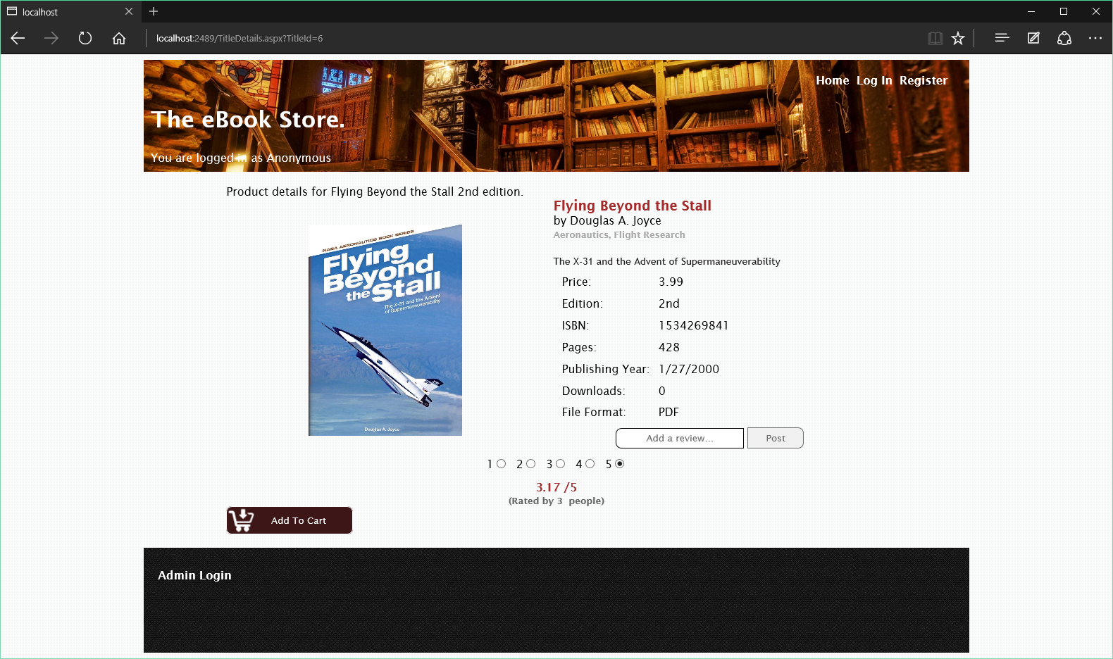

Title Details

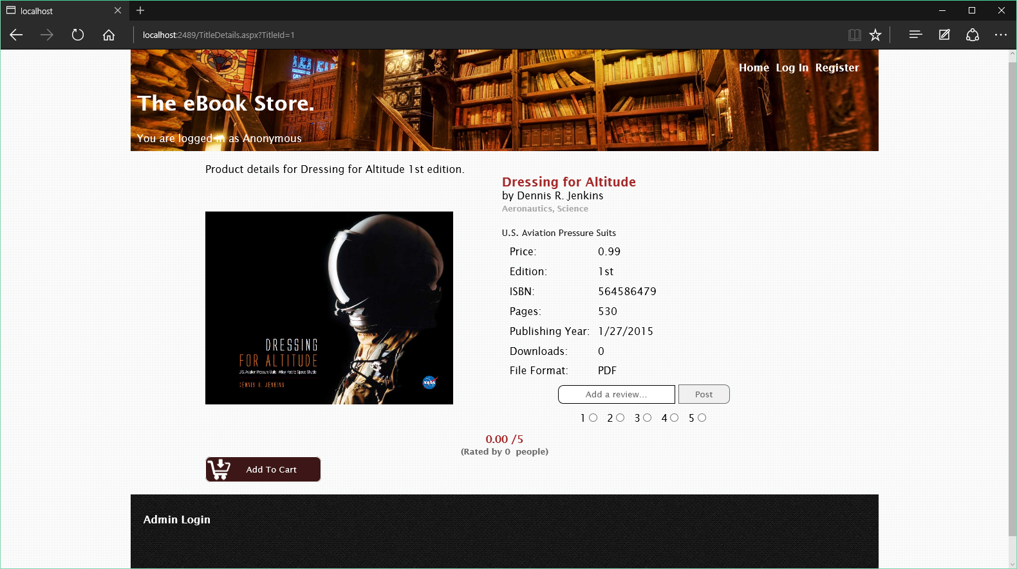Title Details

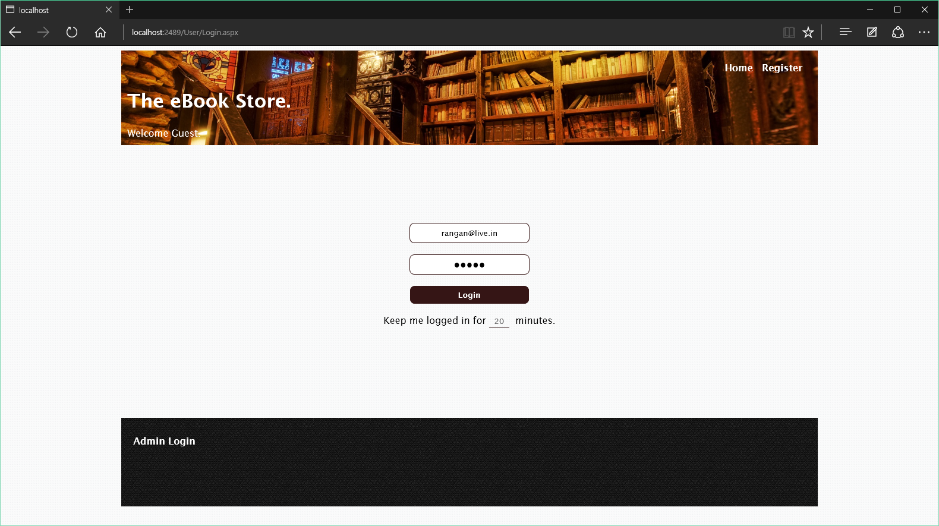

User Login Page

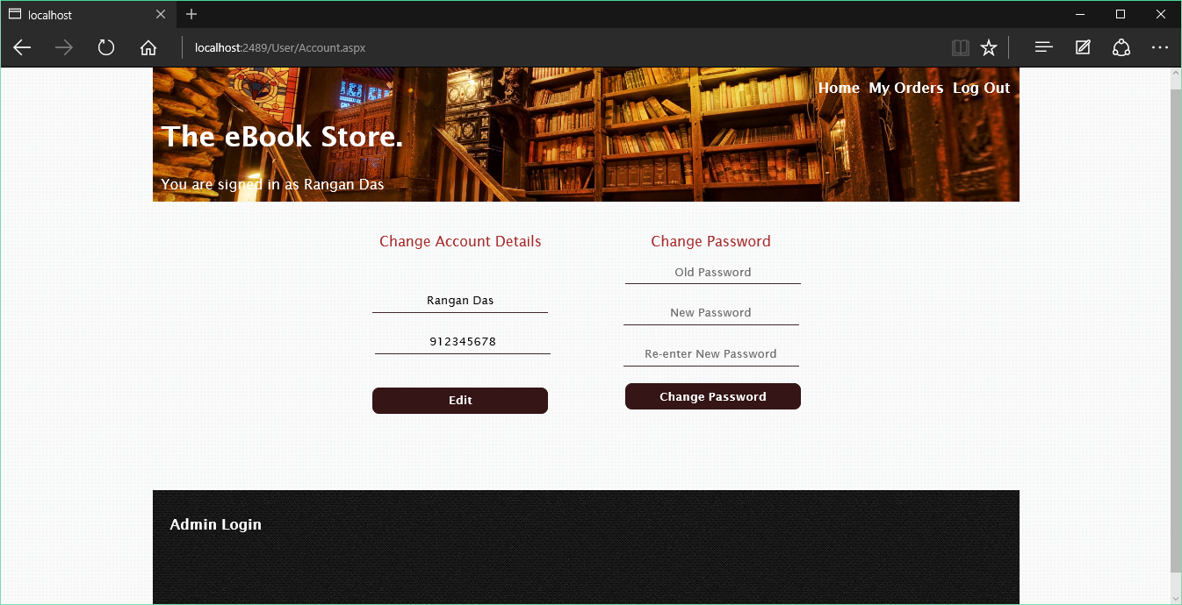

User Account Details

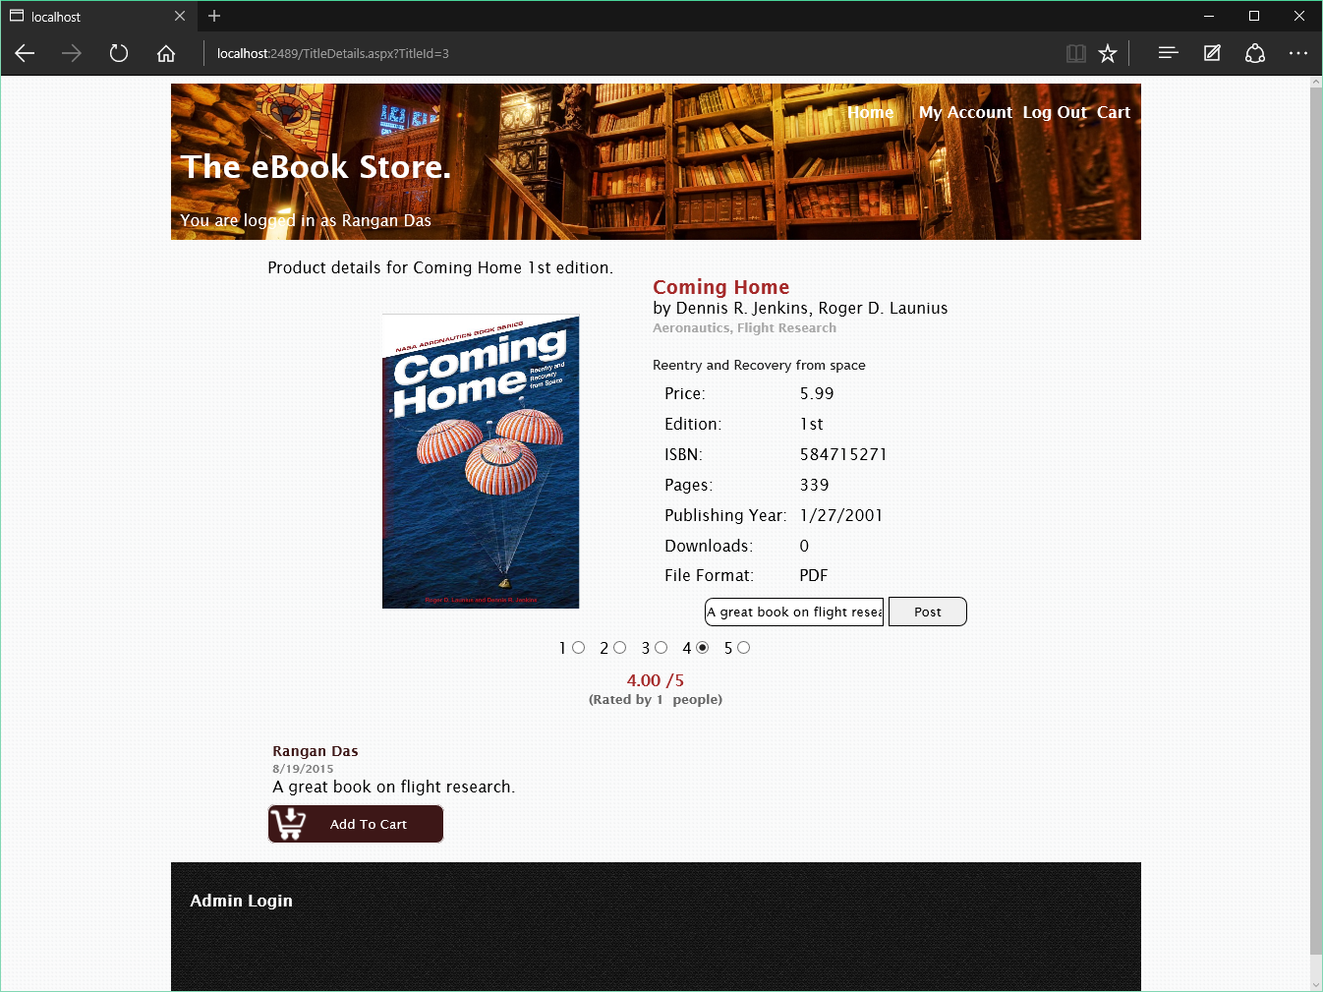

Title Details showing reviews

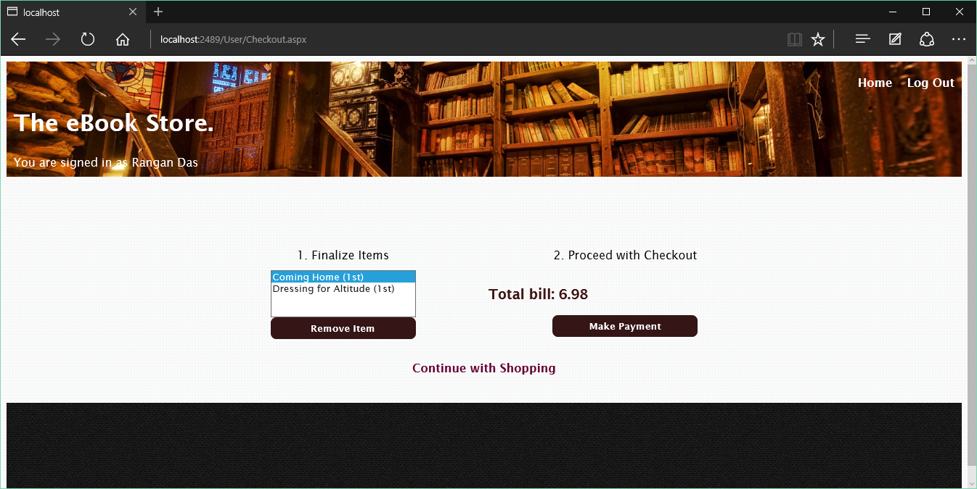

Checkout Page

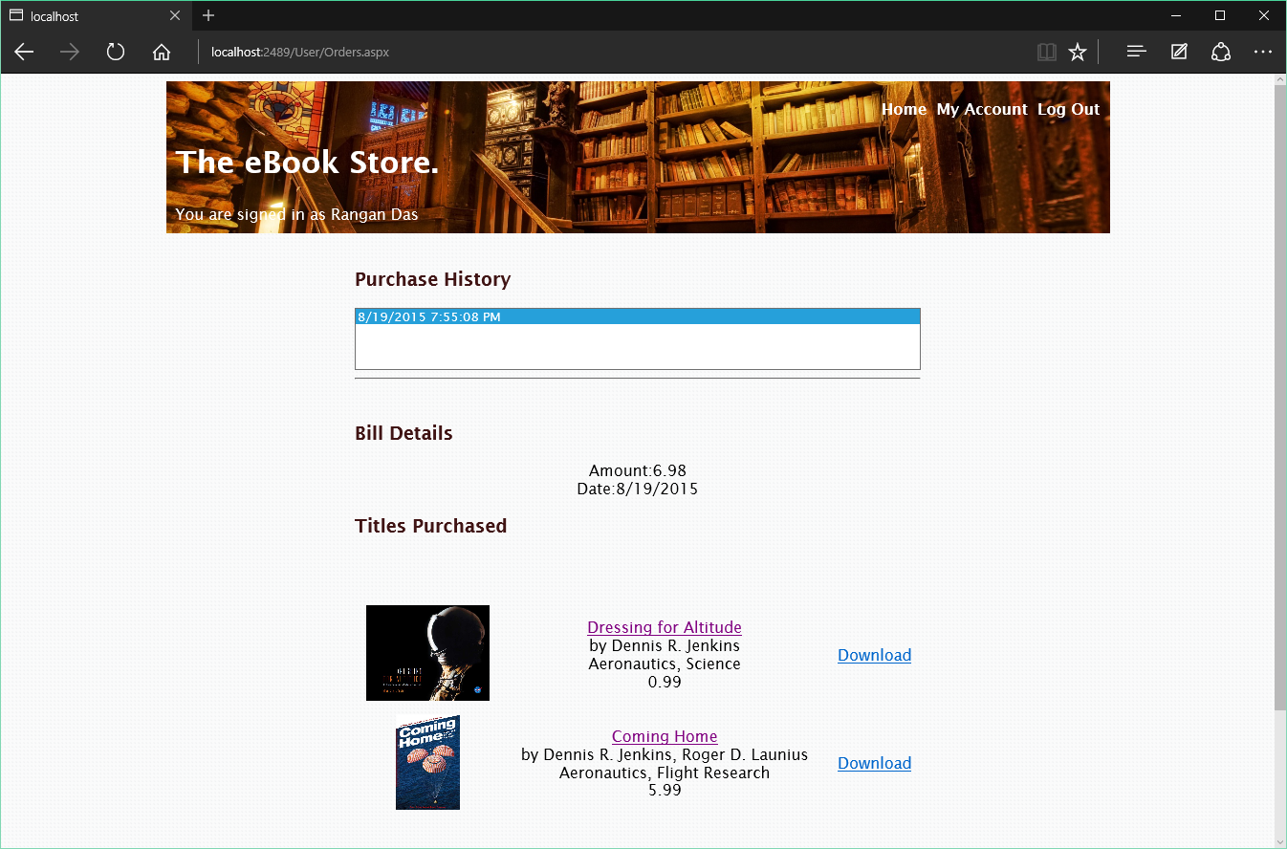

Orders Page showing download links

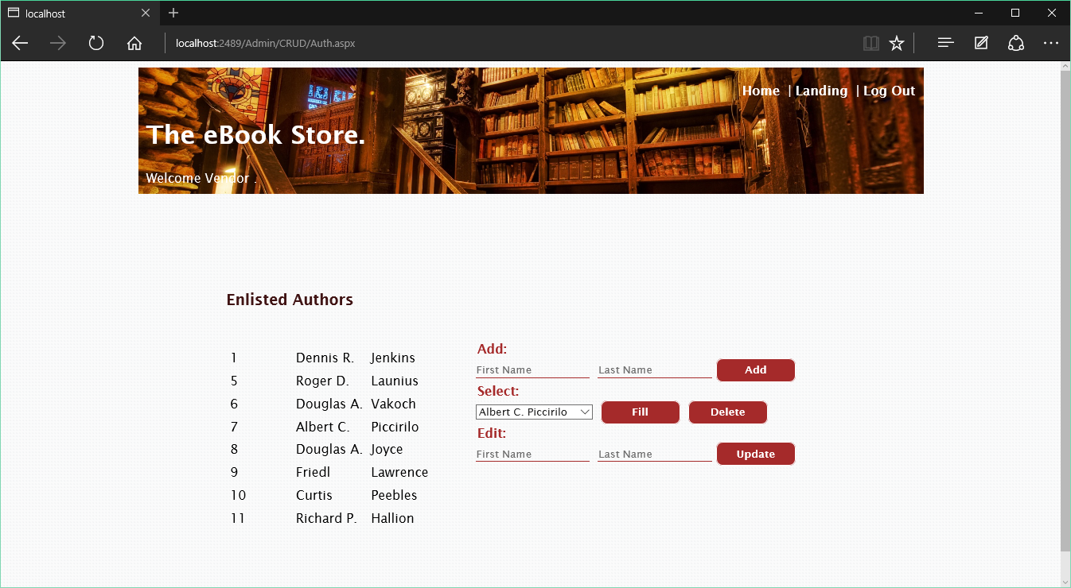

Authors Management Page

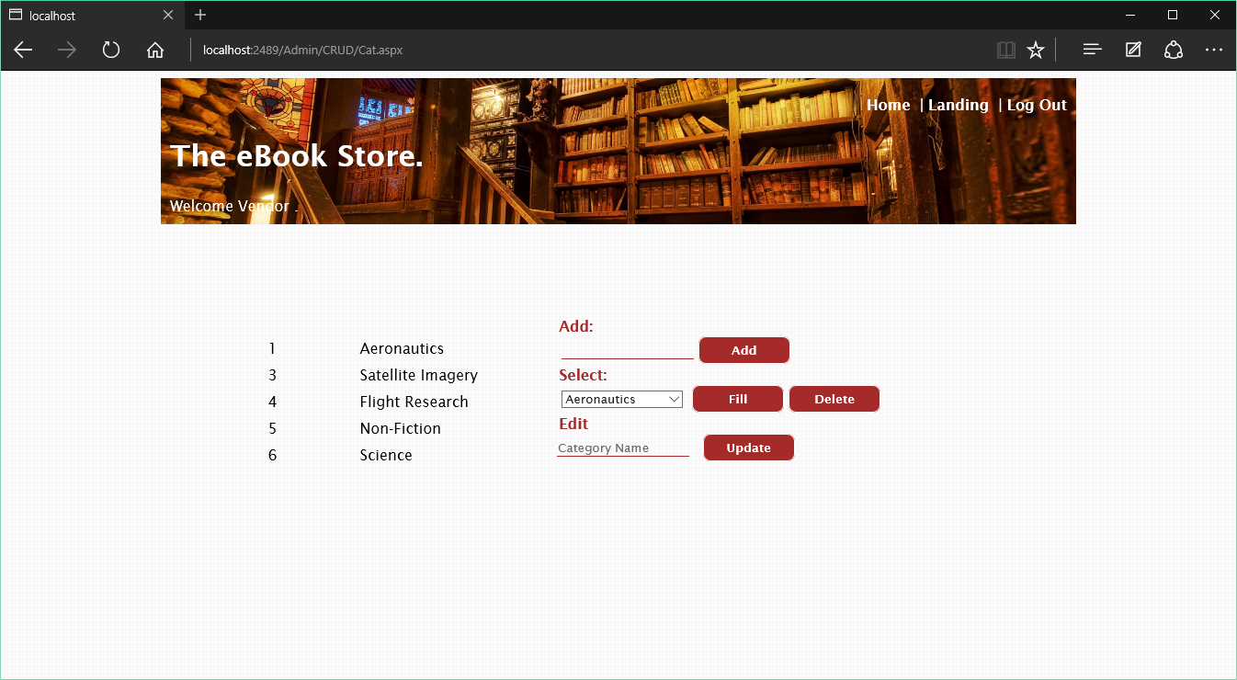

Categories Page

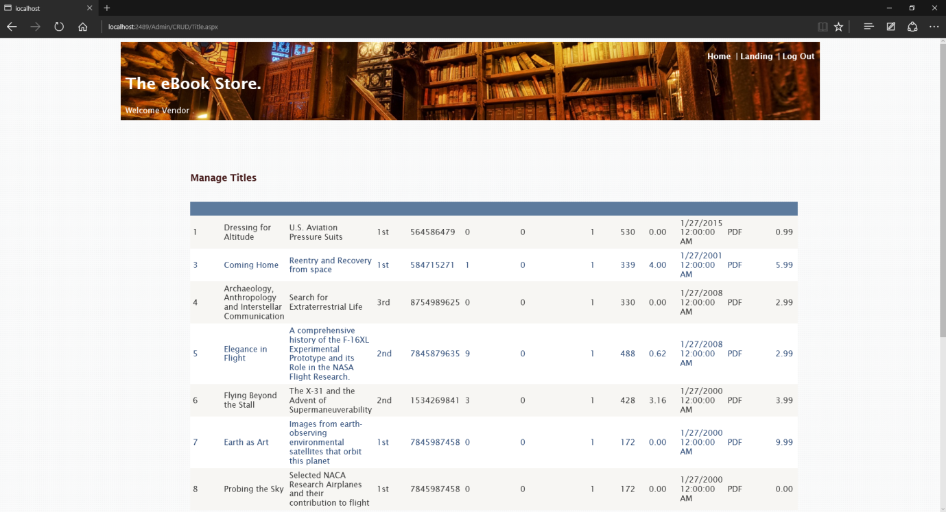

Titles Management Page

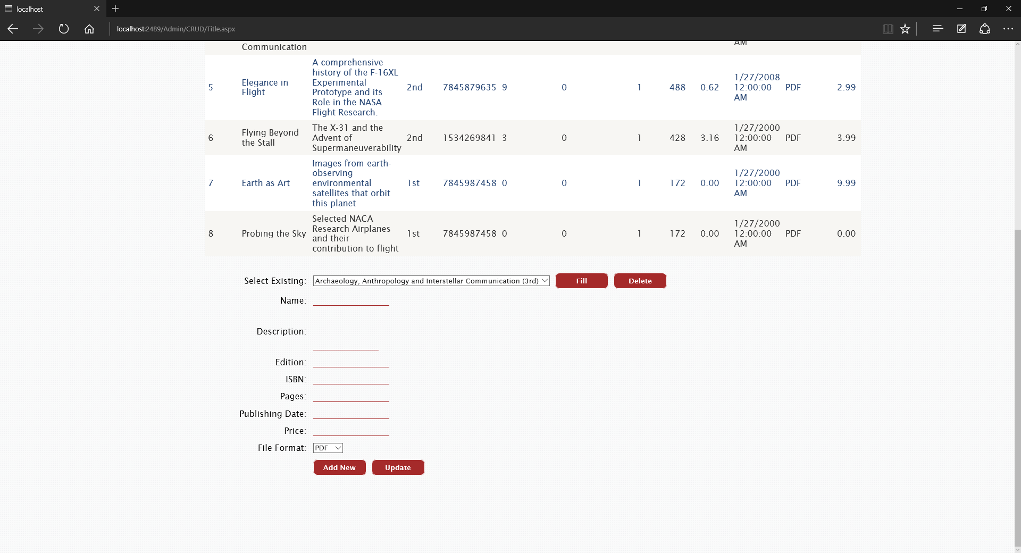

Titles Management Page

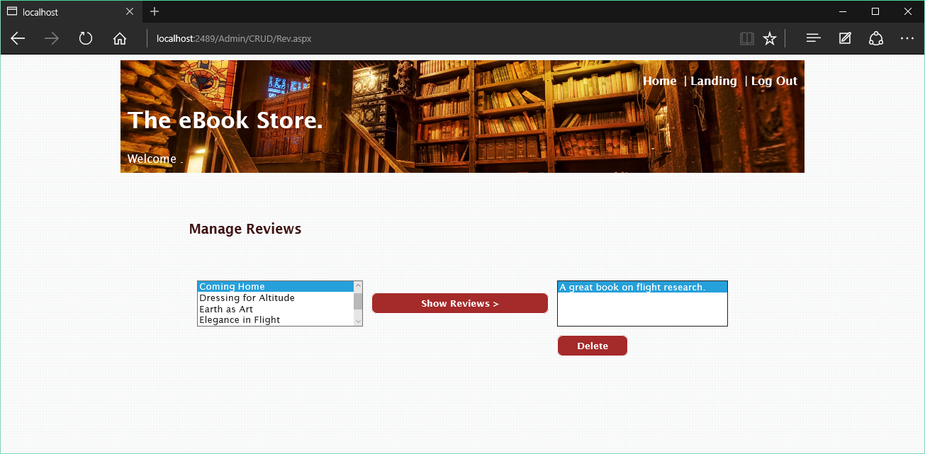

Reviews Management

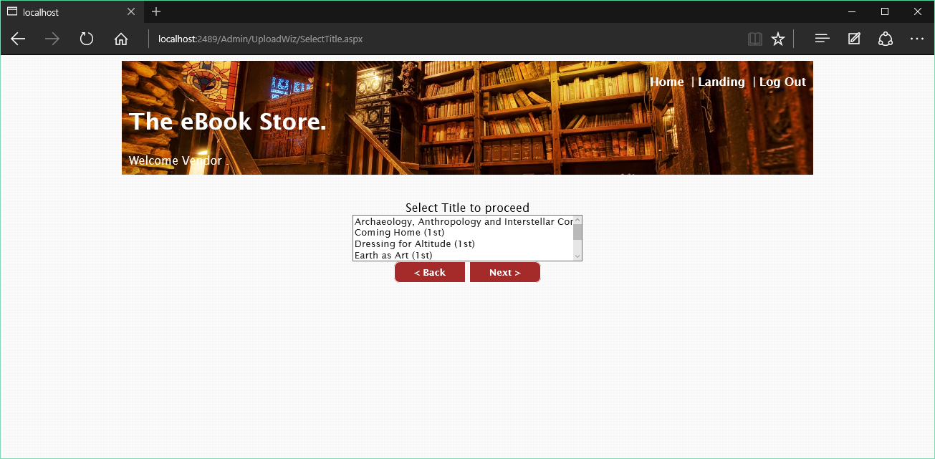

Upload Wizard – Title Selection

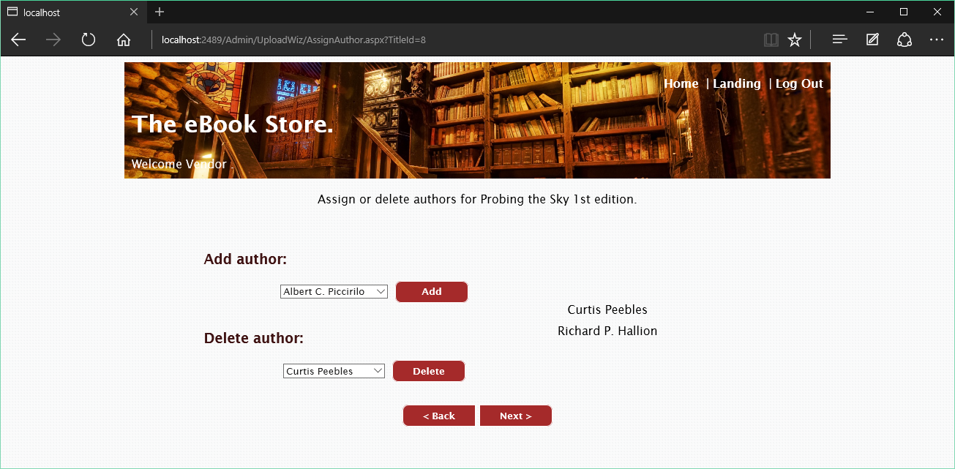

Upload Wizard – Add Author

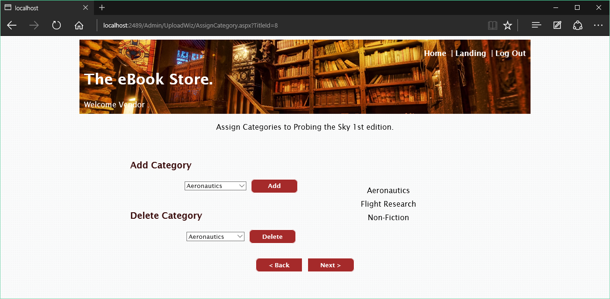

Upload Wizard – Add Category

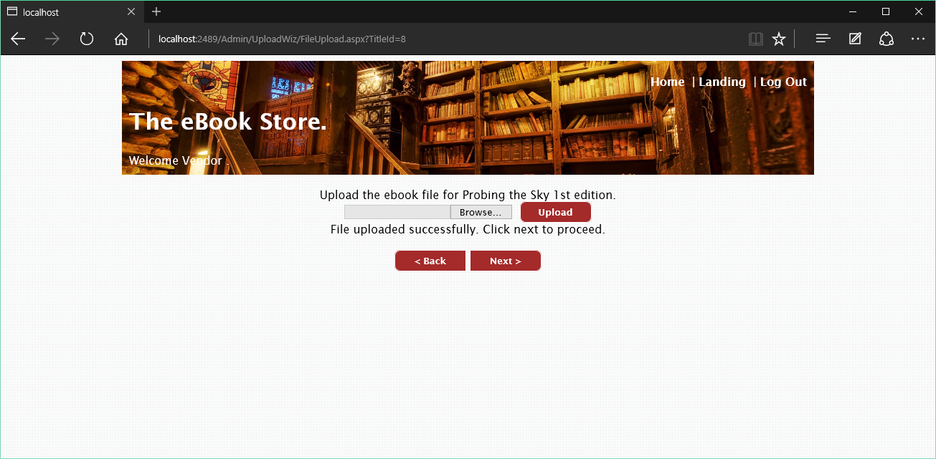

File Upload

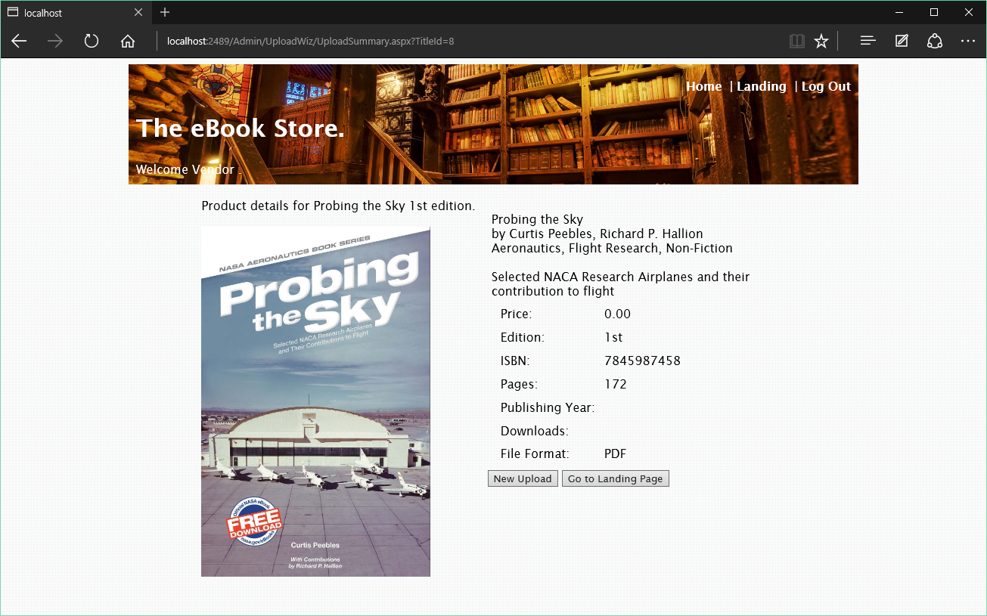

Upload Summary

# Future Scope

The future scope of the of this project can be the following

* **Providing more relevant content to the user in the home page**
  + An authenticated user will get customized content on his or her home page based on the their previous purchases
  + Cookies will be used to track user’s choices for more relevant content.
* **Storing the cart items into a permanent store**
  + The database will store the cart items for a user even when the user has logged out.
* **Better delivery of eBooks**
  + An email containing the link of the eBook will be delivered to the user.
  + Links will also be available from the orders page.
  + Searching of purchased eBooks will also be supported.
* **Online eBook reader for increased compatibility**
  + Devices which has only a browser, but not an eBook reader should be able to open the purchased eBook in the browser itself.
* **Better Interaction amongst users**
  + Users will be able to reply to comments.
  + Users can interact with the administrator or the vendor.

# Bibliography

The following books and websites were referred to while this project was being made

* Asp.Net: The Complete Reference 1st Edition by Matthew MacDonald
* Professional C# 5.0 and the .NET 4.5 Framework 6th Edition by Andrew Troelsen
* PluralSight – Getting Started with Entity Framework 6.0
* Channel 9 Official Site – channel9.msdn.com
* Microsoft Virtual Academy - www.microsoftvirtualacademy.com
* Stack Overflow – www.stackoverflow.com
* Code Project – www.codeproject.com